A watershed-specific formula to predict coho salmon reproduction using river flow metrics

Claire Kouba, Jason Weiner and Thomas Harter

Nov. 2023

# Abstract

In many rural areas in arid and semi-arid regions, balancing agricultural and environmental water demands is a key challenge facing resource managers. Although flow-ecology relationships are well-studied, the water needs of cultivated crops are generally better understood than those of aquatic ecosystems. In particular, the timing and magnitude of flow needed to sustain key ecological functions remain poorly quantified in many regions. This work aims to quantify hydrologic conditions that support persistence of key ecosystem species. We use the coho (*Oncorhynchus kisutch*) and Chinook (*Oncorhynchus tshawytscha*) salmon run in Scott Valley, a 2,109 km2 undammed rural watershed in northern California, USA, as a case study. We applied the functional flows framework to characterize the hydrology of each water year measured at a key long-term stream gauge. Taking advantage of a nearly two-decade ecological monitoring dataset, we used lasso regression to build predictive models of coho and Chinook salmon reproductive success using hydrologic metrics as predictors.

To control for cohort effects, we chose normalized ecological response metrics for coho and Chinook (number of outmigrating smolt per spawning adult or spawning adult female). For both species, we calculated optimal predictive models for thousands of subsamples of the datasets, and tested them on the remaining observations. We selected a lambda value for each species based on a balance between the average test error and the percent of variability explained by predictors. These lambda values were used to calculate a final predictive model, or Hydrologic Benefit function, using the full dataset for each species. We found that variation in coho outcomes was more predictable, using fewer hydrologic metrics, than for Chinook salmon. We further found that the top-performing hydrologic predictors were **x, y and z** for coho and **x, y and z** for Chinook outcomes.

This method for empirically deriving the highest-priority hydrologic functions for a threatened species could be used in other watersheds (if sufficient ecological data records are available, and if flow-hydrology relationships are identifiable for a given species) to evaluate trade-offs and support water management decisions in human-altered novel ecosystems.

# 1 Introduction

## 1.1 Motivation and objectives

Reconciliation ecology posits that some human-impacted ecosystems should be considered irrevocably-altered, “novel” systems (Moyle 2014), with their own specific management concerns. To implement this philosophy, rather than working to restore novel ecosystems to pre-human conditions, a natural resource manager would embrace a role as earth system engineer, and would actively manage biodiversity in human-altered landscapes as a co-equal goal with extracting and cultivating natural resources to provide for human material needs (e.g., Robertson and Swinton 2005; Arthington, Bernardo, and Ilhéu 2014; Acreman et al. 2014). But critical knowledge gaps are abundant and make this dual objective seem intractable. In many river ecosystems, though general methods to characterize environmental flows have been in wide use for at least a decade (e.g., Poff and Zimmerman 2010; Shenton et al. 2012; Solans and García de Jalón 2016), the regional-scale conditions that would maintain biodiversity are as yet unquantified or highly uncertain (Poff et al. 2010). Higher certainty in quantitative ecological targets could support more robust decision making and trade-off analysis, potentially answering questions like: how close can managers get to the desired ecological conditions, and at what cost, particularly in a changing climate?

In practice, these questions are often asked and answered locally (Tarlock 1993). The entities managing natural resources, and thus determining the regional persistence of non-human species, are typically the communities living and working with local resources. Reflecting this reality, the authors of this study have posed research questions tailored to conserving two specific salmon species, the threatened coho salmon (*Oncorhynchus kisutch*) and the less-threatened Chinook salmon (*Onchorhynchus tshawytscha*), in a specific study area: the Scott River watershed in northern California, USA. In this undammed, rural watershed, the primary way to manage water use is by managing land use, and balancing the competing water needs of fish and farmers is a key challenge for local water managers (Siskiyou County 2021). Agricultural water needs are well-known and can be estimated and scheduled (Siskiyou RCD 1994; Parry 2013; DWR 2021), but, in spite of decades of investigation by local, state and federal actors (e.g., SRWC and Siskiyou RCD 2003; NMFS 2014; CDFW 2015b; CDFW 2021), the ecological water needs in this balancing act are not as well constrained.

One method for estimating ecological water needs is the functional flows framework (Poff et al. 1997; Poff and Zimmerman 2010). Functional flow metrics are used to quantify potential ecological services provided by river flow in terms of flowrate amplitude, timing, frequency, and duration in distinct seasons of a water year, where water year is here defined to begin on October 1 of the year preceding the calendar year of the same number (i.e., water year 2020 begins on October 1, 2019). Recent work has refined these metrics for California hydrology and made the metric-calculating algorithms publicly available (Yarnell et al. 2020; Patterson et al. 2020).

To learn if it is possible to empirically quantify a hydrologic regime that meets the ecological needs of specific species (coho and Chinook salmon) in a specific ecological region (the Scott River watershed), we examine correlations between several dozen hydrologic metrics and local salmon observations. We then used lasso regression to select hydrologic metric predictors and predict salmon outcomes. The result of the predictor selection was a Hydrologic Benefit function for each species, conceptually translating the various ecological services provided by hydrology across different seasons into a single value (in units of ecological observations) per water year. This work sets the stage for a quantitative comparison of competing natural resource management alternatives.

## 1.2 History of flow-ecology relationships

A river’s flow regime is often referred to as a “master variable” controlling geomorphic, chemical, and other conditions in its aquatic ecosystems, and organisms that have evolved to persist in specific flow regimes are commonly negatively affected by flow alteration (Bunn and Arthington 2002; Poff and Zimmerman 2010). Consequently, in recent decades a diverse body of research has sought to identify and quantify ecological responses to changes in flow. Work on this topic spans multiple categories of ecological response, hydrologic predictor, and ultimate cause of hydrologic alteration. Two widely studied ecological response metric categories are, firstly, the stream health index, based on density and species richness of macroinvertebrates observed at designated sampling sites (e.g., Monk et al. 2006; Guareschi et al. 2014; Kevic et al. 2018; Mazor et al. 2018; Larsen et al. 2021; Peek et al. 2022), and secondly, and fish diversity and community assemblage [e.g., Ryan A. McManamay et al. (2013); Peterson and Freeman (2016); Cartwright et al. (2017); Sinnathamby et al. (2018); Hain et al. (2018); Guedes et al. (2020); Yao et al. (2021)). Ecological responses can also be based on the abundance of a single or a few species, often of fish (Stewart-Koster et al. 2011; Booth et al. 2014; DeWeber and Peterson 2020; Hale et al. 2023), as well as the extent of habitat types (Chowdhury and Driver 2007; Brand et al. 2011) and the presence of organisms including vegetation and plankton (Riis et al. 2008; Catford et al. 2014; Qian, Liu, and Chen 2016; Tesfaye et al. 2017; Saby et al. 2022). Hydrologic predictors range widely, with a heavy emphasis on extreme (low or high) flow events and the duration of components of the flow regime (e.g., Ayllón et al. 2014; Lamouroux and Olivier 2015; Ryan A. McManamay and Frimpong 2015; Bower et al. 2022). Causes of the change in hydrology include the operation of dams, changes in human water use, climate change, and natural flow variability (e.g., Alomía Herrera and Carrera Burneo 2017; Gao, Xie, and Zou 2020; White et al. 2018; Daneshvar et al. 2017; Herbst et al. 2019).

Investigations of flow-ecology relationships can also be grouped by approach (as in Brummer et al. 2016). In experimental flow studies the flow is directly manipulated with dam releases and biological responses are monitored (e.g., Konrad et al. 2011). In longitudinal studies, long-term ecological and hydrological records can be used to infer local or regional correlations (e.g., Mellado-Díaz et al. 2019). Finally, in space-for-time approaches, the hydrology of multiple river systems in a region is used to populate the distribution of different hydrologic behavior, and ecological monitoring in this region is assumed to be related to flow differences between streams (e.g., Monk et al. 2008; Riis et al. 2008; Catford et al. 2014; Bower et al. 2022). Space-for-time analyses require considerably fewer resources than experimental flows and longitudinal studies, and thus are more numerous (Brummer et al. 2016). Frequently in space-for-time analyses the flow change is quantified in terms of hydrologic alteration from a natural or historical regime, as in the Ecological Limits of Hydrologic Alteration (ELOHA) framework (Richter et al. 2006; Poff et al. 2010). ELOHA and other methods to identify natural flow regimes are adaptable and have been applied widely to many distinct regional systems (e.g., Knight et al. 2014; Brummer et al. 2016; Bower et al. 2022).

Bridging the gap between science and policy has been a persistent challenge in this field. In many cases a key research motivation is to support decision-making in a variety of contexts, including dam operation, river restoration, and regulations of water extraction and land use (Richter et al. 2006; Han et al. 2015; Sinnathamby et al. 2018; Bradley et al. 2017; Brummer et al. 2016). But historical approaches based on relationship-finding are several steps removed from the policy-making process (Webb et al. 2018). For example, ELOHA or similar approaches can generate flow-ecology relationships or flow standards for particular rivers, but cannot translate specific management decisions into hydrologic or ecological outcomes (Cartwright et al. 2017). Additionally, studies of multiple stressors on river systems suggest that flow changes alone are not enough to predict ecological response at regional, multi-basin scales (e.g., Worrall et al. 2014; Knight et al. 2014; Ryan A. McManamay et al. 2013; Ryan A. McManamay and Frimpong 2015) or in some single basins (e.g., Acero Triana, Chu, and Stein 2021). Finally, many flow-ecology relationships are based on insufficient data. Methods have been proposed to mitigate this, but the exercise is generally inhibited by small sample size of relevant ecological metrics (Gwinn et al. 2016).

An ideal framework for supporting decision-making would involve two key steps, firstly connecting management actions to flow changes, and secondly connecting flow changes to ecological responses (Peterson and Freeman 2016; DeWeber and Peterson 2020; Acero Triana, Chu, and Stein 2021). Both steps can involve complex models and substantial uncertainty, often representing an interdisciplinary challenge. Threshold values for “sufficient” flows would be ideal for a management context (J. S. Rosenfeld 2017), but can be difficult to identify and in some cases may not exist (Lueders and McManamay 2023). Additionally, identifying natural flow regimes may be less immediately relevant to water resource management than an approach which can quantify ecological responses to “designer” or functional flows (which can often be controlled or influenced by dam releases) (Arthington, Bernardo, and Ilhéu 2014; Webb et al. 2018), though some may suggest that all possible historical flow components should be preserved (e.g., Bower et al. 2022), as the designer flows approach may risk overlooking ecological flow needs that are not currently monitored. Finally, stakeholders in at least one study requested flow-ecology relationships based on empirical monitoring, rather than more easily-simulated proxies like flow changes or thermal exposure (DeWeber and Peterson 2020).

The present study is a longitudinal analysis, using empirical data and a case study, to address the second of the two key links identified above. We use empirical data to predict a biological response to measurable (and simulatable) changes in flow metrics. We refer to this prediction as a “hydrologic benefit function” (i.e., intending to quantify the ecological services provided by flow) for a single species. This provides the critical link to evaluate fish outcomes resulting from future alternative watershed management practices which affect the hydrology of a stream ecosystem. A forthcoming companion study will investigate the other link, predicting flow changes from watershed management actions using an appropriate hydrologic model, then use hydrologic benefit functions to summarize the ecologic outcomes of a portfolio of water and land use scenarios.

# 2 Methods: Case study setting and species of concern

Exploring the empirical relationship between river hydrology and an ecological response requires overlapping geography, and sufficient record length, in a study area’s hydrologic and ecological monitoring data.

These requirements are met to some degree in Scott Valley, though as is typical, ecological data is the limiting factor. Hydrologic data is provided by daily river flow monitoring, which has been ongoing since the 1940s at the USGS stream gauge downstream of the town of Fort Jones (Station ID #11519500, or the Fort Jones Gauge or FJ Gauge; Figure 1). The flow at this gauge is correlated with flow in tributary streams (Foglia et al. 2013), and though a single monitoring location may not be able represent flow status in the full stream system at all times, it has been used in recent water planning documents as an indicator of overall hydrologic conditions (Siskiyou County 2021). Because most water use in Scott Valley occurs upgradient of this gauge, its measurements are used to inform water management decisions in the populated areas of the valley.

Ecologic data is available due to routine monitoring of spawning anadromous fish, which has been ongoing in the broader Klamath basin since at least 1978 (Knechtle and Chesney 2012). More in-depth monitoring of multiple salmonid life stages in the Scott River watershed has occurred since 2003 (e.g., Maurer 2003; Knechtle and Giudice 2021). In this study we will take advantage of this nearly two-decade record of adult spawner and juvenile salmon abundance observations to draw preliminary conclusions regarding this hydrology-ecology relationship.

## [1] FALSE

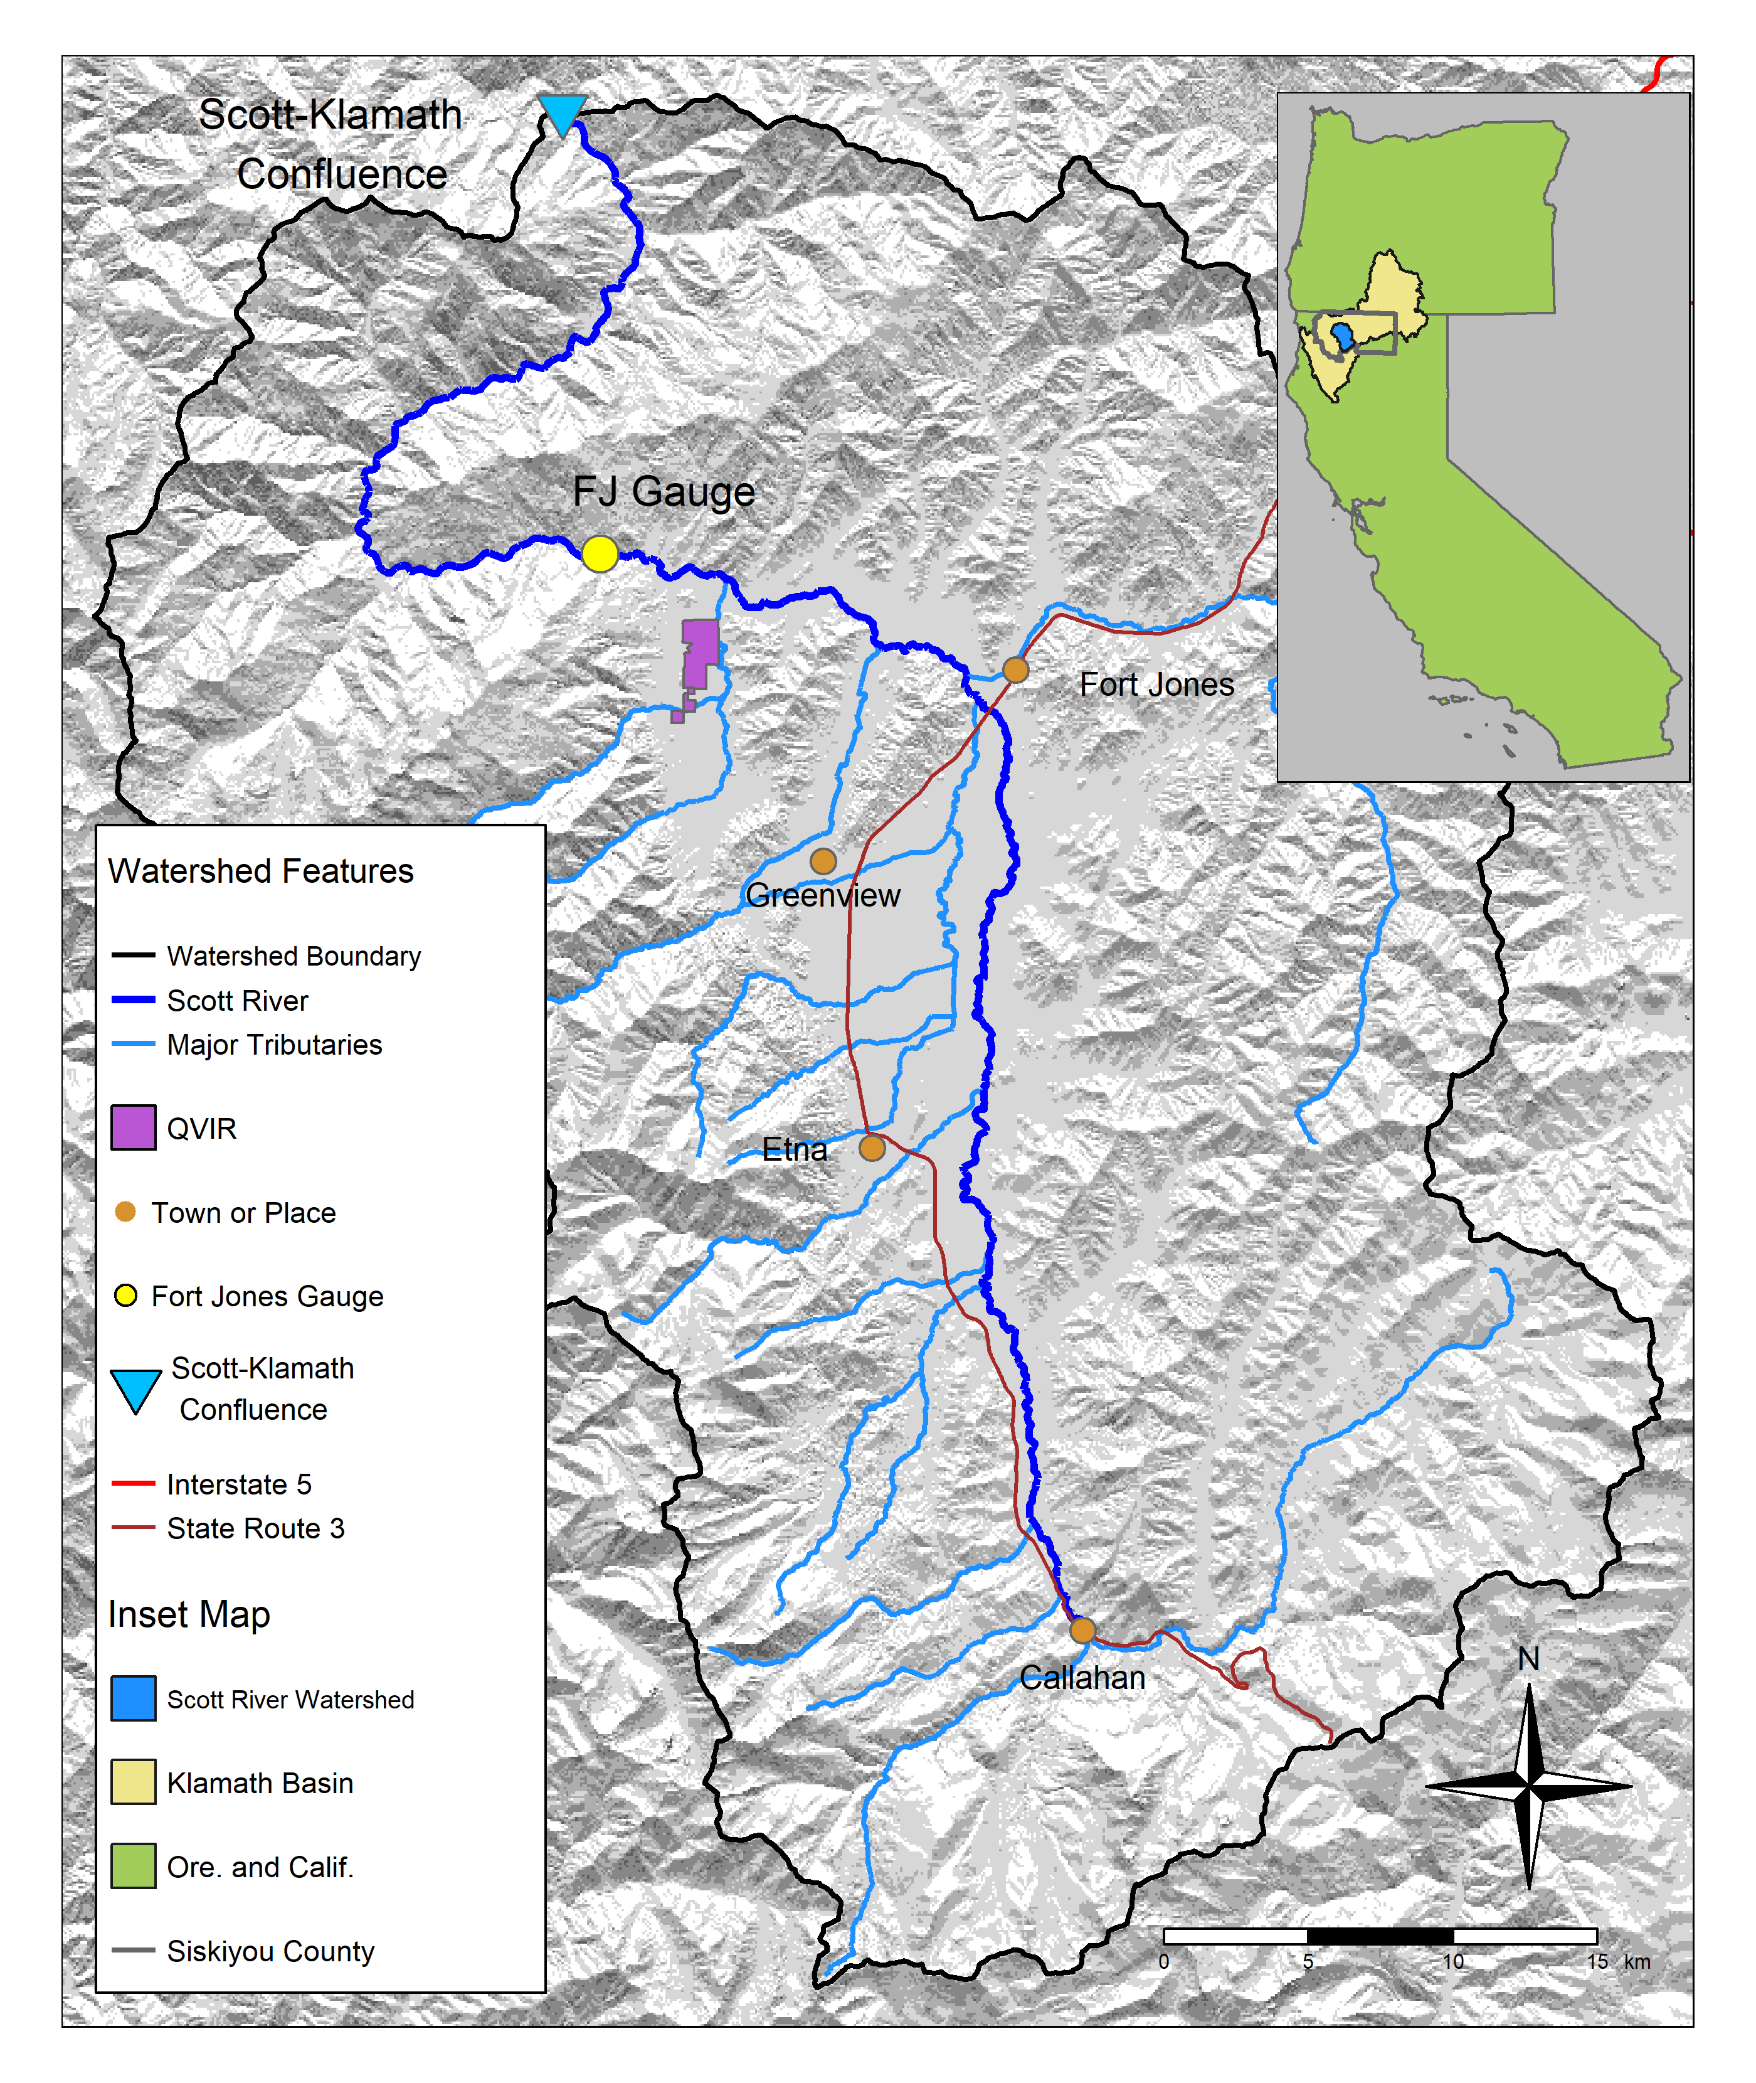

Figure 1: The Scott River watershed, with regional geographic context (see inset) and local features. Scott River flows generally from south to north and joins the Klamath after flowing through a steep canyon.

## 2.1 Scott River watershed setting and water use

### 2.1.1 Geography, climate and hydrology

The Scott River drains a 2,109 km2 (814 square mile) watershed known as Scott Valley, and is a major tributary to the Klamath River, which drains an area spanning sections of Northern California and Southern Oregon (Figure 1). Scott Valley has a Mediterranean climate with distinctive seasons of cool, wet winters and warm, dry summers. This seasonality in water input creates highly seasonal flow in the Scott River and tributary streams (Figure 2). The beginning of a water year therefore coincides with the late low flow season and immediately precedes the onset of first winter precipitation.

In most dry-to-average water years, sections of the Scott River become seasonally dewatered (NCRWQCB 2005; Figure 5 in Tolley, Foglia, and Harter 2019). This occurs when the elevation of the water table drops below the bottom of the river channel, as streams and groundwater are highly interconnected in the Scott River watershed. Tributary streams, particularly along their alluvial fan apeces, and the Scott River are sources of recharge to the aquifer (Mack 1958; Harter and Hines 2008). Groundwater discharge sustains streamflow in some areas, especially during the dry season of August through October or November (Tolley, Foglia, and Harter 2019).

## png   
## 2

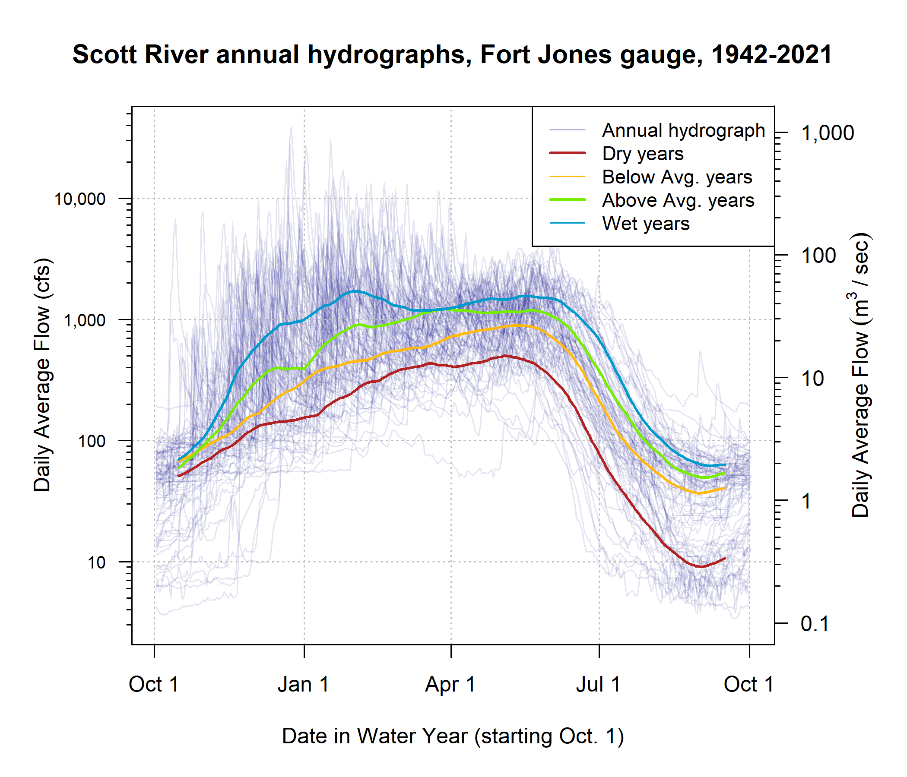

Figure 2: The Mediterranean climate produces highly seasonal flows in the Scott River. Each translucent line traces one annual hydrograph measured at the Fort Jones gauge, and the darker lines illustrate the 30-day smoothed median daily flow in Dry, Below Average, Above Average, and Wet water year types, for water years 1942-2021. The water year type is defined by quartiles of the distribution of total annual flow.

### 2.1.2 Water uses and management objectives

Water in Scott Valley is used for agricultural, domestic, and municipal supply. It also facilitates recreation and provides Native American cultural services, among other designated beneficial uses (NCRWQCB 2006). Because the watershed is undammed, managers and water users influence Scott River flow primarily via diversion of surface waters and pumping of groundwater. Consequently, the most powerful tool available to manage Scott River water flow is regulation of land use and thus water demand (Siskiyou County 2021).

Scott Valley is not a census-designated place and therefore does not have an official population estimate; however, census block-level population data, area-weighted according to the fraction of each block that overlaps with the watershed, indicate that in 2020 the population of the Scott River watershed was approximately 5,186 (U.S. Census Bureau 2021). Most reside outside the boundaries of the two incorporated towns Fort Jones and Etna, with estimated populations of 695 and 678, respectively (U.S. Census Bureau 2021).

Historically, local regulation of land use has focused on maintaining the rural and agricultural character of Scott Valley (Scott Valley Area Plan Committee 1980). Regulating land use to improve ecological outcomes would entail significant economic, political and social risks, because much of the economic activity in this area is related to agriculture. The primary crops grown in Scott Valley are pasture for cattle feed and alfalfa (Siskiyou County 2021). In addition to local economic impact, Scott River conditions influence fish population dynamics both within the watershed and in the broader Klamath system. The health of the Klamath salmon run has implications for commercial fishing, recreational activities, and cultural practices of Native American tribes in the region, including the Quartz Valley Indian Community and the Karuk and Yurok Tribes (Graham 2012).

All of the regulatory and management programs in this region, including recommended instream flows (CDFW 2017), recent emergency drought measures (SWRCB 2022), and legal rights governing surface water diversion (Superior Court of Siskiyou County 1980), are tabulated in units of cubic feet per second (cfs). For consistency, this document will also use primarily cfs units.

## 2.2 Species of concern: coho and Chinook salmon

This study intends to predict the hydrologic needs of two species, coho and Chinook salmon. To this end, we used several decades worth of hydrologic and ecological data collected in the Scott River watershed. Although both species need fall flows to migrate from the ocean to natal spawning streams, the life history strategies of these two salmonids are distinct in several ways, and consequently we anticipate some differences in the functional flows needed to sustain the two species.

### 2.2.1 Salmon management and monitoring in the Scott River watershed

Over the past three decades, several organizations and agencies have conducted extensive monitoring and published a series of reports and plans regarding the salmon fisheries in the Scott River watershed. In the 1990s, fall flows in the Scott River were reported to be too low in some years to allow for Chinook spawning in September-November (CRMP and SRWC 2000), but in the mid-2000s it was reported that low fall flows rarely affected the later (November-January) spawning runs of steelhead and coho salmon (SRWC 2005). More recently, fall flows have affected coho salmon as well as Chinook, as the late onset of winter storms has delayed coho spawning in some water years (e.g., CDFW 2015a). In the mid-2000s, a local conservation organization identified the lack of suitable summer and winter rearing habitat as a probable limitation on Scott River coho smolt production (SRWC and Siskiyou RCD 2005). Several years later, in a NOAA Fisheries Coho Recovery Plan, NMFS identified the juvenile life stage as the most limited in the population (NMFS 2014).

Monitoring activity in the past 20 years has included population estimates from a video counting flume and a rotary screw trap operated by CDFW (CDFW 2015b; Massie and Morrow 2020; Knechtle and Giudice 2023), and spawning surveys for Chinook (Siskiyou RCD 2015b, 2017b, 2018) and coho (Maurer 2003; Siskiyou RCD 2005, 2006, 2010, 2011, 2012, 2013, 2014, 2015a, 2017a; Quigley 2007). Recent management activity has included the leasing of surface water rights from landowners to enhance summer flows (e.g., SRWT 2018), the prioritization of stream reaches for habitat restoration (SRWC 2018), several pilot projects to construct and assess the impact of beaver dam analogs (BDAs) on aquatic habitat and fish populations (Yokel 2018), a coordinated rescue effort to relocate juvenile salmon that were cut off from outmigrating by disconnected river reaches (CDFW 2015a), and the development of long-term groundwater management plan by Siskiyou County and local stakeholders (Siskiyou County 2021).

### 2.2.2 Life cycle and status of coho salmon (*Oncorhynchus kisutch*)

Returning adult coho spawn in natal streams between November and January (Knechtle and Giudice 2020), and juvenile coho spend approximately one full year in freshwater streams before migrating to the ocean as smolts (Moyle 2002; McMahon 1983). In the Scott River system these natal streams are the tributaries along the margins of the valley floor (Siskiyou RCD 2004).

In previous studies, the strongest predictor of juvenile coho abundance in a stream system was spatial habitat (Bradford et al. 2016; Nickelson et al. 1992; Bustard and Narver 1975), although adequate food and cover were also important (McMahon 1983). The primary mechanism for spatial constraints on abundance appears to be that juvenile coho become more territorial as they grow (McMahon 1983).

An average coho life cycle is illustrated in Figure 3. Some coho salmon return to spawn at age 2 as grilse, but the majority (e.g., 92.4% in 2020) return after more than one year in the ocean, giving the Scott coho salmon run its characteristic 3-year cohort return interval (Knechtle and Giudice 2021).

Coho salmon in the Scott Valley are listed as threatened under the federal and California Endangered Species Acts (ESAs). They belong to the Southern Oregon / Northern California Coast (SONCC) Evolutionarily Significant Unit (ESU), which was listed as threatened under the federal and state ESAs in 1997 and 2005, respectively. State-wide, coho populations have declined more than 90% since the 1940s (Brown, Moyle, and Yoshiyama 1994).

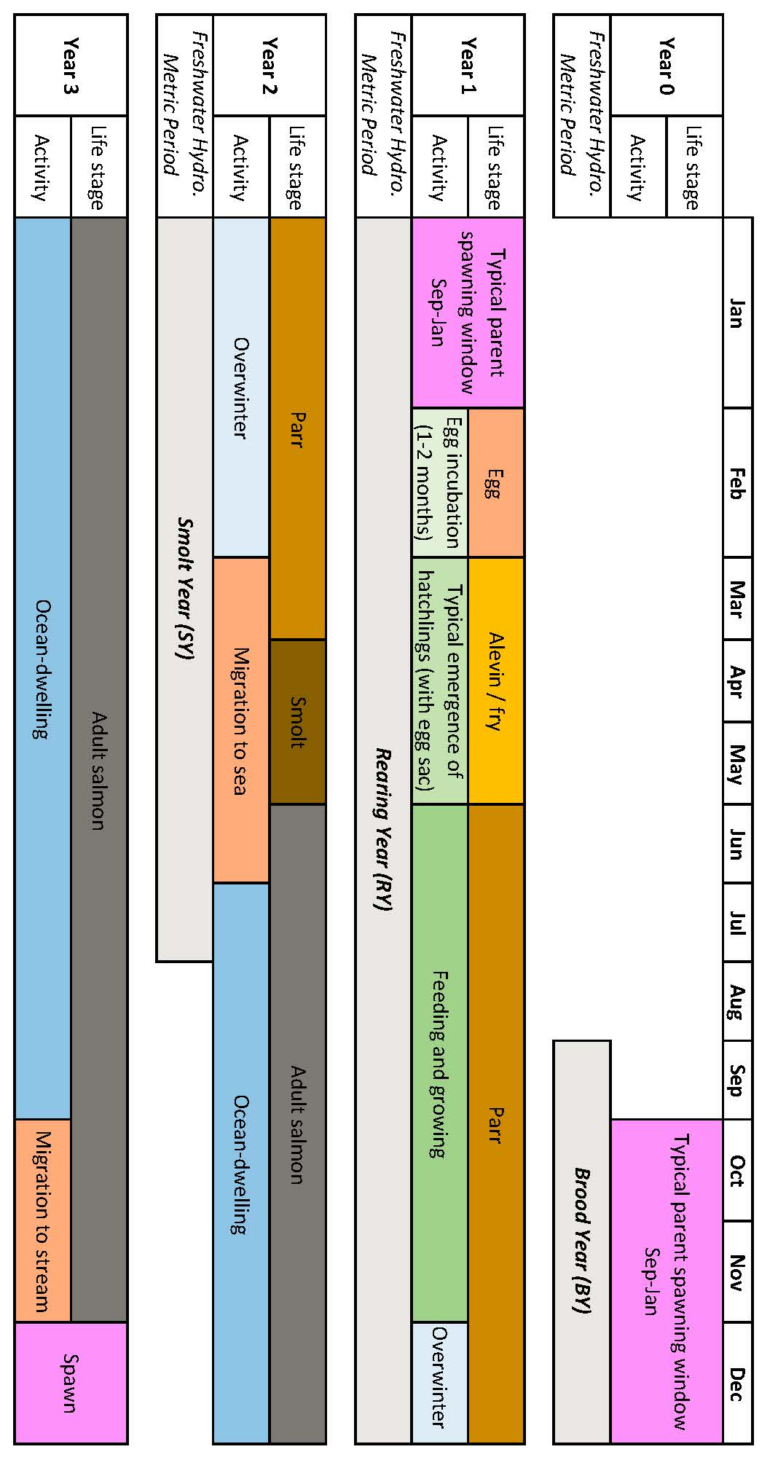

Figure 3: Typical life stage progression of coho salmon in the Scott River watershed.

### 2.2.3 Life cycle and status of Chinook salmon (*Onchorhynchus tsawytscha*)

Chinook salmon in the Scott Valley are a candidate for listing under the federal ESA, and are not listed under the California ESA. They belong to the Southern Oregon / Northern California Coast (SONCC) Evolutionarily Significant Unit (ESU). Typically, adult Chinook salmon return to spawn in Scott Valley streams in the fall months September-December when flows are sufficient for salmon passage (Knechtle and Giudice 2020; Siskiyou RCD 2015a, 2017b). Chinook in this watershed hatch in the spring and migrate to the ocean in their first year of life (Agrawal et al. 2005). Chinook spend the majority of their life in the ocean, and return to their natal streams shortly before spawning (Healey 1991). However, substantial variability exists within this broader structure: Chinook salmon exhibit variation in multiple life stages, including time of seaward migration, age of maturity, and timing of return to natal stream (Healey 1991; Bourret, Caudill, and Keefer 2016). Consequently, a diagram of the Chinook life cycle would include more variability than the more structured coho life cycle reflected in Figure 3.

As recently as 2013, the SONCC Chinook population was stable and becoming more complex (Wainwright et al. 2013). However, in monitoring from 2015-2020, the number of returning adults (the escapement) was 65% below historical average, and the change in the Scott River Chinook population has been more rapid than the decline in the overall Klamath Basin Chinook run (California Department of Fish and Wildlife (CDFW) 2021). Ocean conditions may have contributed to a broad decline in Chinook populations from Alaska to California (Welch, Porter, and Rechisky 2021). Some studies have found that the leading cause of declining Chinook populations are ocean conditions, including including temperature, upwelling currents and food resources (Hunt, Mulligan, and Komori 1999), while others have identified hatchery practices as the primary cause (Quiñones et al. 2014).

### 2.2.4 Relevant distinctions in Chinook and coho life histories

Chinook and coho salmon are distinct in several ways relevant to this study and to management considerations:

* In most years Chinook spawning migration takes place earlier (September-December) than coho (October-January).
* Chinook in this watershed hatch in the spring and migrate to the ocean in their first year of life, in contrast to coho, which spend a full year in the stream before migrating (Agrawal et al. 2005; Knechtle and Giudice 2020).
* Coho salmon prefer to spawn in reaches with smaller spawning gravels than Chinook salmon. Consequently the majority of coho redds are found in Scott River tributaries, while Chinook redds are more commonly found in the mainstem Scott River (e.g., Siskiyou RCD 2017b, 2017b).
* Declining populations of coho salmon have been noted in the Klamath basin and more broadly in coastal California streams since the 1990s (e.g., Brown, Moyle, and Yoshiyama 1994), while regional Chinook populations have historically been more robust (Wainwright et al. 2013). However, a declining trend was observed in the Klamath run of Chinook in the 2010s, and this trend was more significant in the Scott River system than the broader Klamath basin (Knechtle and Giudice 2021). These trends have prompted additional monitoring of Scott Valley Chinook in the past decade (e.g., spawning surveys such as Siskiyou RCD 2015b, 2017b).

# 3 Methods: Quantitative analysis

We used lasso regression (James et al. 2013; Ranstam and Cook 2018) to assess the feasibility of predicting an ecological response using dozens of potential hydrologic predictor metrics. The objectives of the lasso exercise were to 1) perform predictor selection, i.e., empirically estimate which hydrologic flows were most related to coho and Chinook reproductive outcomes and 2) estimate the uncertainty of a predictive Hydrologic Benefit formula, using the selected set of predictors and their calculated coefficients. Each step in the analysis is numbered and explained below.

## 3.1 Step 1. Calculate predictors: Flow metrics to describe Scott River flow regime

Hydrologic predictors consist of flow metrics calculated from the daily flow record at the Fort Jones river gauge from 1942-2021. The full suite of metrics is calculated on a water-year basis (i.e., each type of metric produces one value for each water year; *Supplemental Table 1*). Abbreviations, relevant time periods and metric calculation details are listed in Table 1.

Firstly, a series of metrics from the catalog of California-specific functional flows (as illustrated in Figure 4) (Yarnell et al. 2020; Patterson et al. 2020) were selected to highlight the history and salient characteristics of the Scott River flow regime over the past eight decades. Additional information is available in Patterson et al. (2020) and supporting documentation. All selected functional flow metrics have some known ecological function or interpretation: Total annual flow is used to evaluate water year type. Phenomena measured with fall metrics, such as fall pulse magnitude and fall pulse timing, provide olfactory migration signals and spawning access to anadromous fish; however, a discrete fall pulse does not occur in every water year. Wet season metrics, such as wet season onset timing and baseflow magnitude, can be used to gauge conditions during egg incubation or the overwintering period for juvenile coho salmon. In particular, frequency and duration of wet season high-flow events (i.e. daily average flow above exceeding a 2-, 5- and 10-year flood) indicate the potential presence of scouring flows. Spring metrics, such as spring flow recession rate of change, occur during the transition from wet to dry season, and indicate conditions during early juvenile salmon rearing as well as the flow available for outmigration from Scott Valley to the ocean. Finally, metrics like the duration and median flow of the dry season indicate the timing and severity of low-flow conditions in which spatial habitat is constrained and connectivity between reaches may be limited.

Secondly, we devised two additional metrics for this study area related to timing of anadromous fish access to preferred spawning habitat (illustrated in Figure 5). These metrics are referred to as “reconnection” and “disconnection” dates. They assume a flow threshold, defined at the Fort Jones gauge, that corresponds to a certain degree of “connectivity” in the Scott River stream system. The date on which this connectivity is lost in the spring/summer or gained in the fall has implications for whether salmon passage exists during the preferred migrating time window. These metrics are related to the California-specific functional flows, namely, the timing and slope of spring recess and the timing of a fall pulse flow (Table 1). More importantly, they add value to this analysis because of their direct relation to fish passage in the watershed.

Finally, to identify the presence of scouring flows [i.e., storm events that can mobilize large amounts of sediment and either bury or wash away salmonid eggs; Scott River Watershed Council (SRWC) (2018)], we calculated the number of days in each year with average daily flow greater than the 90th flow percentile (for the full Fort Jones hydrologic record).

### 3.1.1 Selecting flow thresholds for dis- and re-connection timing

When calculating the timing of river connectivity, a discrete number of thresholds were selected from the continuum of flows, ranging between a lowest value of 8 cfs and highest value of 1000 cfs. At the lowest value all tributaries are known to be disconnected and significant dry reaches exist along the main stem, while the highest value is associated with winter storm events in a fully-connected river system (Tolley, Foglia, and Harter 2019).

The reconnection timing of proximate flow thresholds is somewhat correlated. The lasso regression is appropriate for this type of data because the method can eliminate some redundancy in predictor information (James et al. 2013).

Table 1: Explanation of hydrologic metrics used in this analysis. Each type of metric, for each threshold value (e.g., 100 cfs or 50th flow percentile), produces one value per water year.

| Abbrev. | Full Name | Thresholds | Description |
| --- | --- | --- | --- |
| recon | River Reconnection Day (for a given life stage and threshold) | 8, 10, 15, 20, 40, 70, 100, 150, 200, 300, 400, 500, 750, 1000 cfs | The day, usually in the fall, on which the Scott River gains a certain degree of connectivity. Defined as the first day on which FJ Gauge flow rises above a designated threshold (e.g., 10 cfs) (units of days after Aug. 31). Assigned to a salmon lifestage using abbreviations such as RY (Rearing Year). Example: RY_recon_10 |
| discon | River Disconnection Day (for a given life stage and threshold) | 8, 10, 15, 20, 40, 70, 100, 150, 200, 300, 400, 500, 750, 1000 cfs | The day, usually in the spring or early summer, on which the Scott River loses a certain degree of connectivity. Defined as the first day on which FJ Gauge flow drops below a designated threshold (e.g., 100 cfs) (units of days after Aug. 31). Assigned to a salmon lifestage using abbreviations such as BY (Brood Year). Example: BY_discon_100 |
| min_flow | Minimum Flow | -- | Minimum average daily flowrate recorded in the relevant period. Months of the designated time period (e.g. Sep-Dec for BY) are added to the column name for clarity. Example: BY_min_flow_sepdec |
| tot_flow | Total Flow | -- | Sum of all daily flow volumes recorded in the relevant period. Months of the designated time period (e.g. Jan-Jul for SY) are added to the column name for clarity. Example: SY_tot_flow_janjul |
| FA_Mag | Fall Pulse Magnitude | -- | Peak magnitude of fall pulse event (maximum daily peak flow during event) (cfs) in relevant lifestage. Example: RY_FA_Mag |
| FA_Tim | Fall Pulse Timing | -- | Start date of fall pulse event in water year days |
| FA_Dur | Fall Pulse Duration | -- | Duration (# of days) of the fall pulse event |
| Wet_BFL_Mag | Wet Season Baseflow Magnitude | Median (50th daily flow percentile) | The magnitude of the median rate of baseflow (i.e., non-storm flow) during the wet season. Abbreviation: Wet_BFL_Mag_50 |
| Wet_Tim | Wet Season Onset Timing | -- | Start date of wet-season in water year days |
| Wet_BFL_Dur | Wet Season Baseflow Duration | -- | Wet-season baseflow duration (# of days from start of wet-season to start of spring season) |
| Peak_Dur | Duration of high-flow events | 2, 5, and 10-year return interval | Number of days exceeding the 2, 5 and 10 year recurrence intervals of annual peak flow (50%, 20%, and 10% exceedance values). |
| Peak_Fre | Frequency of high-flow events | 2, 5, and 10-year return interval | Number of events exceeding the 2, 5 and 10 year recurrence intervals of annual peak flow (50%, 20%, and 10% exceedance values). |
| num_days_gt_90_pctile | Number of days of high-flow events | 90th flow percentile | Number of days in an annual period (i.e. the Rearing Year) in which the FJ daily average flow exceeded the 90th percentile flowrate in the full FJ Gauge record. |
| SP_Tim | Spring Onset Timing | -- | Start date of spring in water year days |
| SP_ROC | Spring Recession Rate of Change | -- | Spring flow recession rate (median daily rate of change over decreasing periods during the recession) |
| DS_Mag | Dry Season Flow Magnitude | 50th and 90th flow percentile | Percentile of daily flow within dry season |
| DS_Tim | Dry Season Onset Timing | -- | Dry-season baseflow start timing (water year day of dry season) |
| DS_Dur_WS | Dry Season Duration | -- | Dry-season baseflow duration (# of days from start of dry season to start of wet season) |

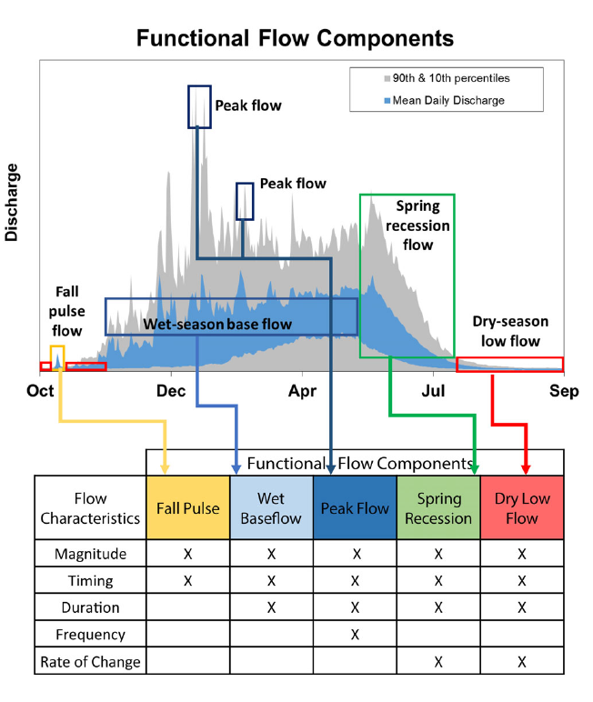

Figure 4: Figure 2 from Yarnell et al., 2020. Illustration of five functional flow categories identified for a mixed rain-snowmelt runoff river in California.

## [1] FALSE

## png   
## 2

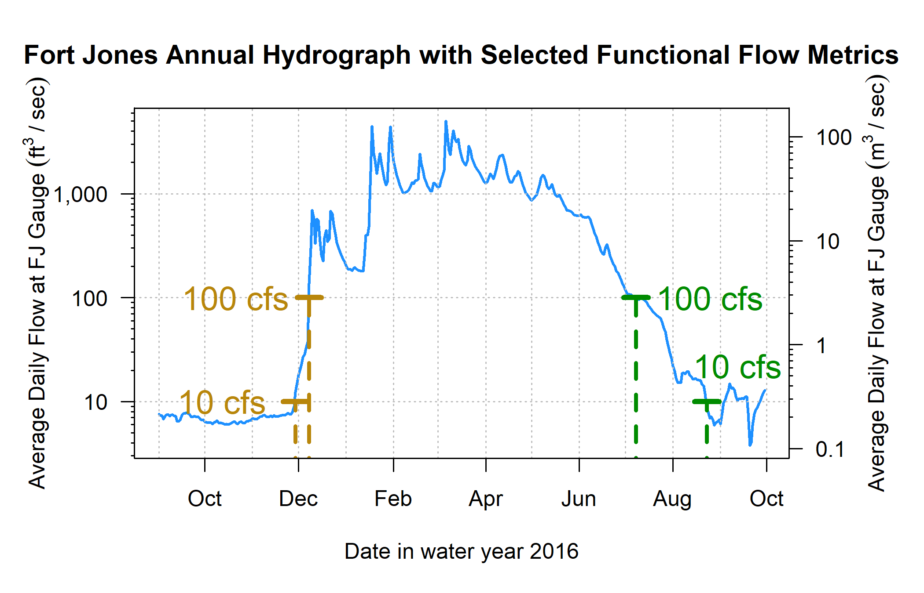

Figure 5: Reconnection and disconnection dates are highlighted for one water year. Two example thresholds, 10 and 100 cfs (0.28 and 2.8 cms, respectively) are highlighted, which correspond to distinct river connectivity (and salmon habitat access) conditions in the Scott River watershed as observed at the Fort Jones gauge (see Results for more detail on selection of flow thresholds).

## 3.2 Step 2. Assemble responses: Ecological monitoring data

Multiple observed quantities were evaluated as candidates to best represent the ecological response in the flow-ecology relationship.

Factors influencing the population size of anadromous fish include ocean conditions and freshwater conditions. In this study, because we are interested only in the conditions in their natal streams, we have focused on fish population metrics that are influenced by the freshwater system. The key ecological observations used in this study are:

1. Number of adults migrating from the ocean to freshwater natal streams to spawn. This quantity, the ‘escapement’, is measured at a CDFW counting facility, using a resistance board weir and video counting flume in the Scott River (e.g., Knechtle and Giudice 2021).
2. Number of juvenile yearling, or smolt, salmon. Smolt are counted as outmigrants, often from rotary screw trap observations (e.g., Massie and Morrow 2020).
3. Number of salmon gravel nests, or redds, observed during spawning window (e.g., Siskiyou RCD 2017a) (for coho only).

Based on these observations, two other combined metrics have historically been calculated and reported by regional agencies (Knechtle and Giudice 2023). These metrics use data from multiple years to capture multiple life stages for a given cohort:

1. The number of outmigrating coho smolt produced per spawning female (coho spf) and the outmigrating Chinook juveniles per adult (Chinook jpa).

## 3.3 Step 3. Align predictor and response metrics with timing of species cohorts

A water year is a useful time unit for water managers and a common unit used in decision-support tools. However, a cohort of, e.g., coho salmon experiences conditions during multiple water years while residing in their spawning habitat. For coho salmon the life cycle is largely regular in Scott Valley, with 3 defined cohorts in which the vast majority of individuals return to natal streams at 3 years of age (e.g., CDFW 2021). Conversely, the majority of Chinook salmon return to spawn when they are 2 to 6 years old (Bourret, Caudill, and Keefer 2016), resulting in less of a cohort structure than for coho. Here we define the alignment (i.e., mapping) of a specific generation of fish (ecological outcome) with hydrologic metrics (predictors) observed across the portion of their life cycle spent in the Scott River system (*Supplemental Table 2*).

### 3.3.1 Data alignment - coho

The relevant unit of time for identifying the impacts of freshwater hydrology on a coho salmon cohort is defined here as a Coho Freshwater Life Period (CFLP), a duration of 21 months beginning the September of the year their parents spawned and ending the July of their outmigration from the watershed as smolts. This time period is conservatively wide; most spawning occurs in October or later, and most outmigration occurs in June or earlier (Moyle 2002), but the September-July duration was chosen to capture critical life stages even in extreme water years.

For convenience in referring to hydrologic metrics in different water years, this Coho Freshwater Life Period has been broken up into three subperiods (as shown in Figure 3 and described in Table 2):

* Brood Year (BY), September-December of the year of the cohort’s parents’ spawning
* Rearing Year (RY), January-December of the full year the cohort spends in the watershed
* Smolt Year (SY), January-July of the year of the cohort’s smolt outmigration

Coho Freshwater Life Periods overlap, e.g., the fall pulse flows in year take place during one cohort’s Brood Year, and the same fall flows occur during the end of the Rearing Year for the cohort born in year . In some rare cases, flow metrics may fall outside their designated subperiods (e.g., the extreme dry water year of 2014, in which the “fall reconnection” of flows in Brood Year 2013 did not occur until February of the cohort’s Rearing Year). Nonetheless, for consistency, even a January or February reconnection date will be referred to by the previous fall year designation.

To build empirical relationships between hydrology and biology, ecological response variables were indexed by Brood Year of the affected cohort and hydrologic metrics tabulated accordingly (*Supplemental Table 2*). For example, the value for fall reconnection timing (100 cfs flow threshold) in fall of 2011 was assigned to the column “BY_recon_100” for the Brood Year 2011 cohort. The same value was assigned to the column “RY_recon_100” for the Brood Year 2010, which experienced fall 2011 as rearing juveniles.

Each brood year is associated with multiple ecological responses (i.e. “fish outcome” observation types), including number of Chinook and coho spawners observed and the estimated number of smolt observed at the end of their CFLP. Data were available and compiled for brood years 2004 through 2019. We note that because the Brood Year period only covers the fall and early winter, ecological outcome in water year is obtained for for both salmon species.

Table 2: Explanation of time period definitions used in this analysis (displayed graphically in Figure 3).

| Abbrev. | Full Name | Description |
| --- | --- | --- |
| BY | Brood Year | September-December window in which spawning occurs (by the parents of the designated cohort). |
| RY | Rearing Year | January-December window during which a cohort hatches and rears in freshwater. |
| SY | Smolt Year | January-July window during which a cohort grows in freshwater and outmigrates to the ocean. |
| CFLP | Coho Freshwater Life Period | The (conservatively wide) 21-month window, September through July, in which members of a cohort or the cohort's spawning parents are present in the freshwater system. |

### 3.3.2 Data alignment - Chinook

Because spawning occurs in the fall for both coho and Chinook salmon in the Scott River watershed (California Department of Fish and Wildlife (CDFW) 2021), Chinook ecological data was aligned with hydrologic metrics in the same manner as coho observations. Distinct life histories produced one significant difference: because Chinook migrate to the ocean in their first year of life, the duration of freshwater residence for each Chinook cohort is shorter than for coho, ranging from fall spawning to the subsequent spring or summer. Thus, only metrics from the Brood Year and from the Rearing Year wet season, spring recession and dry season were considered for Chinook predictions.

## 3.4 Step 4. Calculate correlation coefficients and rule out temporally impossible relationships

After aligning the hydrologic predictors and ecological responses, we calculated Pearson correlation coefficients (Pearson 1895) between each predictor and each response. A significant number of potential predictor-response pairs do not represent a temporally plausible relationship: e.g., the wet season values in water year 2011 would not influence the number of spawners that arrived the previous season, in fall of 2010. These implausible pairs were excluded from the resulting matrix.

## 3.5 Step 5. Select ecological response metrics

To generate predictive models, we make an assumption of independence for each year of ecological observation data. Cohort effects may reduce the validity of this assumption (i.e. the number of spawners in year 2009 may be partly dependent on the number of spawners in 2006). In order to control somewhat for cohort effects, we selected the normalized metric available for each species: coho smolts per female spawner (coho spf) and Chinook juveniles per adult spawner (Chinook jpa). We used the correlation coefficents between the hydrologic and ecological metrics to assess the predictability of the two data types. For completeness, we also compared the values of the two selected metrics to the other (non-normalized) ecological data types.

## 3.6 Step 6. Generate predictive model with lasso regression

With hydrologic metrics assigned to each salmon generation, indexed by brood-year (*Supplemental Table 2*), we assessed the potential for hydrologic metrics to predict biological outcomes by performing lasso regression (James et al. 2013; Ranstam and Cook 2018) between 88 hydrologic predictors and the two ecological metrics selected in the previous step (one for coho and one for Chinook).

### 3.6.1 General approach

We used the R programming environment (R Core Team 2020) and the linear modeling function glmnet() (Friedman, Hastie, and Tibshirani 2010) to perform variable selection using lasso regression. Lasso regression is less flexible than the classic least squares regression, and is commonly used in high-dimensional data settings, where the number of possible predictors approaches or exceeds the number of observations (James et al. 2013). Because the solution can set some coefficients to 0, thereby removing their associated predictors from the final model, lasso regression can also perform predictor selection.

Lasso (Least Absolute Shrinkage and Selection Operator) regression minimizes the following quantity:

Where:

* is the number of ecological observations;
* enumerates the brood years;
* is the number of predictors;
* enumerates the hydrologic predictors;
* is the observed value of hydrologic predictor for brood year (independent variable);
* is the observed value of ecological response in brood year (dependent variable);
* is the intercept value for the resulting linear model;
* is the coefficient value for hydrologic predictor in the resulting linear model; and
* is a tuning parameter, referred to as a shrinkage penalty.

In this formulation, sufficiently large values of lambda generally shrink the values of all coefficients to 0 (the infinite-lambda case). The infinite-lambda case produces a model consisting solely of the intercept term, which takes on a value that is the average of all the observed values. Conversely, sufficiently small values of will produce linear models incorporating information from many predictors. The selection of the appropriate value is a critical step in the regression procedure, and is best done using cross-validation within the training dataset (James et al. 2013). In this analysis a range of values was explored for each species.

### 3.6.2 Predictor restriction based on sample size

Some ecological records have gaps (e.g., when funding was not available in one year to conduct a redd survey). Additionally, some predictor metrics are not available in all years (i.e., FA_Mag, or magnitude of a fall pulse flow, cannot be calculated if no discrete fall pulse flow is observed). For the lasso regression exercise, we restricted the set of considered predictors to those which had at least 10 years of overlap with the selected ecological response.

### 3.6.3 Test error and range of lambda values

In lasso regression, the goal is to select a lambda value (referred to as the “shrinkage penalty” or “tuning parameter”) that uses available predictor data to explain the maximum amount of deviation in the response while avoiding overfitting. With high-dimensional data, it is typically possible to perfectly fit the observations (explaining 100% of deviation) by incorporating data from a number of predictors that approaches or exceeds the number of observations (James et al. 2013). The predictive models that result from this type of overfitting typically perform poorly when applied to new data, since they tend to incorporate random noise to achieve a perfect fit (James et al. 2013).

The standard method to pick the optimal value of lambda is to divide a dataset into a “training” and a “test” set, and use the training set to generate a series of regression models using a range of lambda values. These models are then used to predict the values of the test set, and the total difference between predicted and observed quantities is known as the test error. This is often summarized as the root mean squared error value (RMSE). The lambda value that produces the regression model with the minimum test error is selected, and using this value, a final regression model is generated based on the full data set (James et al. 2013).

However, we decided this was not appropriate for the size of the available ecological datasets, which ranged from 13 to 21 years of observations: we could not be confident that the optimal lambda value was an indicator of the optimal balance point between incorporating useful information and overfitting, since it could just be an artefact of the way we divided the dataset into test and training sets. To address this, we tried to identify the range of all optimal lambda values possible within the available ecological dataset. We reserved (the rounded up integer corresponding to) 25% of the observations as the test set, generated up to 10,000 non-repeating random sets of testing and training data, and calculated the optimal lambda value for each set.

Then, using the full dataset, we calculated regression models produced by the full range of optimal lambda values identified in the test-train step.

### 3.6.4 Selection of final lambda values

To select a final lambda value, we considered the percentage of deviation explained and the test error of the 1,366 (coho) and 10,000 (Chinook) randomly sampled test and training sets. For both species we selected a lambda value that explained the maximum percent of deviation that also produced a reasonable average test error.

## 3.7 Step 7. Formulate Hydrologic Benefit function

The final lambda value selection produced the linear model which can be used to predict ecological outcomes with hydrologic predictors. We referred to this model as the Hydrologic Benefit (HB) function. The predicted HB value, with units of the selected ecological response type, in Brood Year is calculated as:

Where: is the value of predictor in the cohort with Brood Year .

As noted above, the ecological outcome in water year is obtained for for both salmon species.

# 4 Results

## 4.1 Flow history of the Scott River, described in functional flow metrics

Diagnostic metrics of Scott River flow have demonstrated clear trends over the past 8 decades. Between 1942 and 2021, total annual flow measured at the Fort Jones gauge has dropped from an average of approximately 600 to 400 thousand acre-feet (TAF, or from >800 to <600 million m3) (Figure 6, panel A). Annual flows have always shown large variability, ranging across an order of magnitude, from 67 TAF (in water year 1977) to 1,336 TAF (in water year 1974). More recently, the frequency of years with low annual flows (200 TAF or less) has significantly increased: 3 such years over the first four decades of the gage record, but 10 such years over the second four decades. In contrast, very high annual flows of over 600 TAF were exceeded in at least five years for each two-decade period between 1941 and 2000, but only twice in the most recent two-decade record.

Ecosystem functional flow metrics, calculated with signal-processing techniques (Patterson et al. 2020) (illustrated in Figure 4), also show clear trends over time (Figure 6, panels B-H). The fall pulse onset date has trended slightly later (though a distinct fall pulse flow does not occur every year), and the magnitude of the fall pulse flows has decreased. Remarkably, a fall pulse onset during the first half of October occurred four times between 1940 and 1980, but not since then (Figure 6, panel C). Reflecting the large variability in annual flows, the magnitude of the fall pulse flow varies widely, across 2.5 orders of magnitude, from less than 50 cfs to 1500 cfs. Extremely high fall pulse flows (>800 cfs), occurring three times in the earlier period, were missing in the second half of the 80-year record. Years with a fall pulse flow magnitudes of less than 400 cfs have become more frequent, resulting in a visible downward trend in fall pulse magnitude over the period of record (Figure 6, panel B).

The onset of the wet season has trended slightly later, though wet season median baseflows (i.e., flows not occurring during storm pulses) have remained stable on average (with a very slight downward trend). Wet season baseflow rates vary from less than 50 cfs (1977) to over 2000 cfs (1997) with typical winter flow ranging from 400 to 1000 cfs (Figure 6, panel E).

After April, the chance of large precipitation events becomes minimal leading to a gradual, near-exponential decline of streamflow rates during May through July as the snowpack in the upper watershed melts off. While a very consistent feature in the annual hydrograph (e.g., Figure 5), the rate of flow reduction (i.e., the exponential decline) during the spring has increased over the period of record. The spring recession curve has grown steeper and accelerated the annual recession process: hhe rate of decline was just above 0.05%/day in 1940, and it was nearly 0.07%/day in 2020 (Figure 6, panel EF).

The median dry season flow has dropped by approximately 50%, with many years since 1977 seeing flows below 30 cfs, a condition not seen prior to 1977 and largely related discontinuation of inefficient flood irrigation with surface water and the introduction of efficient sprinkler irrigation with groundwater during the 1970s (Tolley, Foglia, and Harter 2019). The onset of the dry season is earlier, and the duration of the dry season has increased, in some of the most recent years to over 200 days (Figure 6, panels G and H).

The reconnection and disconnection dates also show significant trends over time. As a result, the wet season has notably narrowed over time with (approximate) fall onset trending later and the spring flow recession trending to begin earlier. In 2020, the expected reconnection at the 100 cfs threshold occurs more than a month later than in 1940, the expected summer disconnection more than two weeks earlier (Figure 7).

In aggregate over the past 80 years, these metrics show an increasing prevalence of unfavorable hydrologic conditions for salmonids, in terms of the flows needed during critical life stages. The primary causes of this reduced ecological functionality are a changing climate (especially a reduced snowpack and earlier snowmelt) and long-term changes in local consumptive water uses (Drake, Tate, and Carlson 2000; Van Kirk and Naman 2008; Foglia et al. 2013).

## png   
## 2

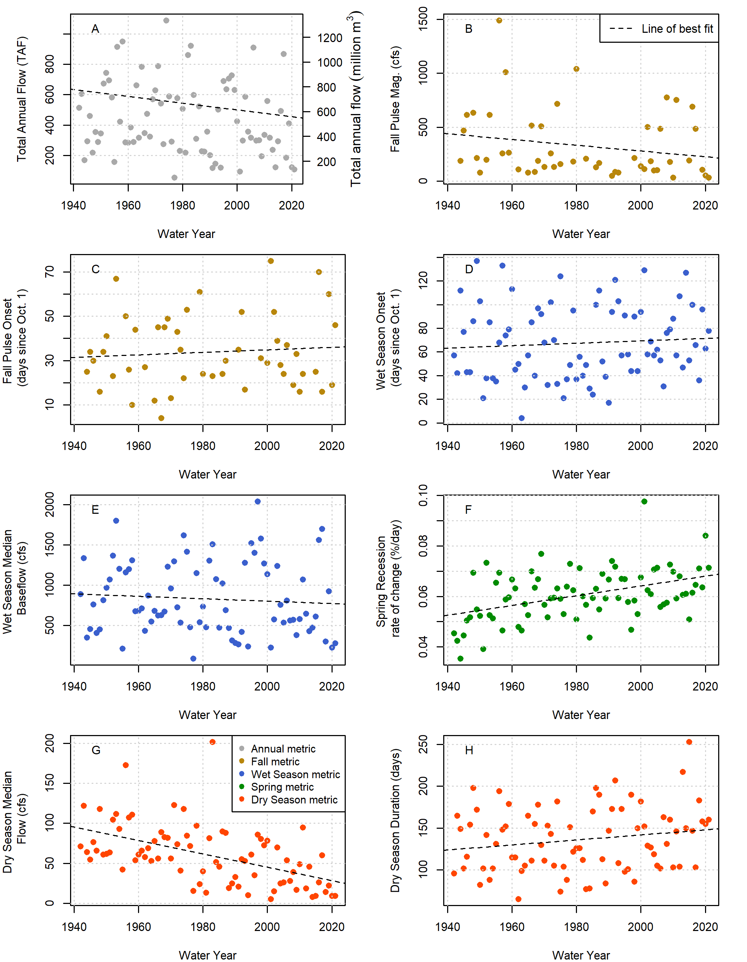

Figure 6: Total annual flow volume (panel A) and functional flow metrics (panels B-H; Patterson et al. 2020), derived from daily average flow measurements at the Fort Jones USGS flow gauge (ID 11519500) for water years 1942-2021.

## png   
## 2

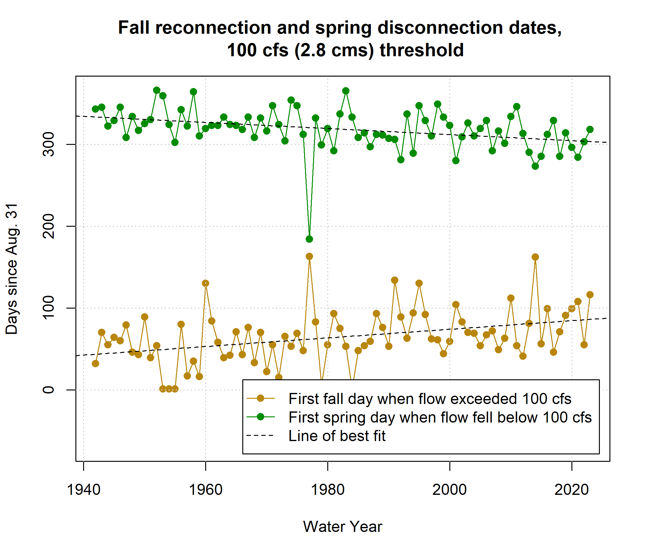

Figure 7: Disconnection and reconnection dates for the 100 cfs (2.8 cms) flow threshold, water years 1942-2021. The disconnection date refers to the first day in the spring on which flow drops below the designated threshold (100 cfs); the reconnection date refers to the first date in the fall on which flow rises above the designated threshold. Trends over the past 80 years suggest that the spring flow recession is trending earlier, and the fall river reconnection is trending later.

## 4.2 Hydrology-ecology correlations

In the correlation analysis we assessed relatedness of ecological outcome metrics with all types of hydrologic metrics (i.e. reconnection/disconnection timing, functional flows, and scouring flow metrics) (*Supplemental Figure 1*; with selected metrics shown in Figure 8).

FALSE png   
FALSE 2

The correlation coefficients do not show uniform effects of hydrology on both species: for example, the brood year reconnection timing produces strong negative correlations with coho spf and weak positive correlations with Chinook jpa (Figure 8). Furthermore, hydrology tends to have different effects on different life stages: for both species the sign of with brood year reconnection timing is the opposite for spawning adults and outmigrating juveniles (though brood year reconnection correlations are much weaker for Chinook than for coho).

The correlation coefficients support several findings that match existing understanding of coho and Chinook ecohydrology. For example, experiencing alonger wet season as newly hatched fry (RY_Wet_BFL_Dur, or rearing year wet season baseflow duration) is associated with higher juvenile abundance for both species. Relatedly, so is a later Rearing Year dry season onset, and a later spring disconnection (in both the rearing and smolt years) is associated with more outmigrating coho smolt. Additionally, a higher number of RY scouring days does seem to be related to lower Chinook outmigrants, whereas it has no relationishp with coho outmigrants.

The correlations also suggest some findings that do not match current understanding. One strong signal is that earlier fall reconnection timing (earlier fall spawning flows) is associated with a higher production of coho spf. In general, earlier fall flows in the brood year are thought to be beneficial to coho salmon, but it appears that this is only true for the number of outmigrating juveniles. The correlations suggest that a higher number of *spawners* is in fact associated with later fall flows. Relatedly, the total flow volume in the four months of the brood year period is also negatively correlated with the number of coho spawners. These two correlations suggest that the apparent benefits of early flows for normalized coho reproduction is partially driven by a negative effect on the denominator (spawners) in addition to a positive effect on the numerator (outmigrating juveniles).

Discussion

* * Why are normalized metrics diff between species? Chinook dependence on mainstem habitat vs tributary habitat for coho. Coho may be more sensitive to fall reconnection timing since they need to traverse more river miles that tend to go dry in the dry season.

## png   
## 2

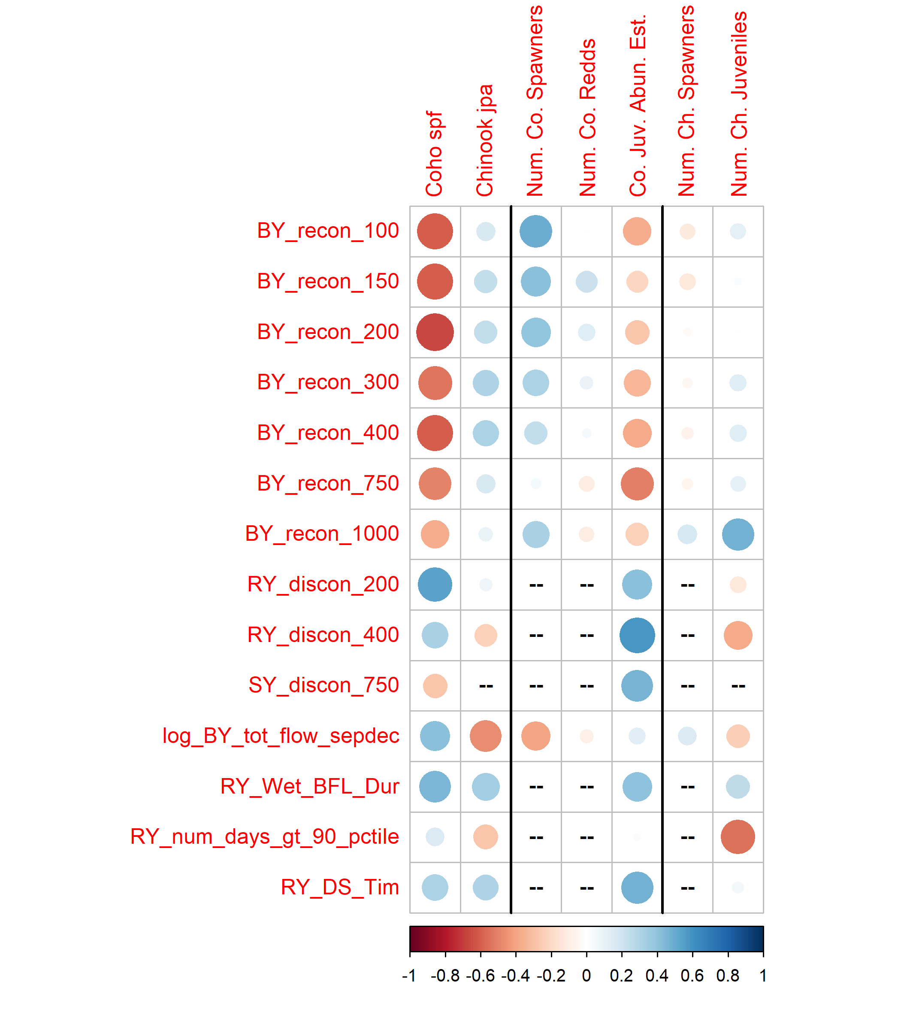

Figure 8: Correlations between 18 predictors and 7 ecological monitoring metrics: the two normalized metrics (left two columns), three additional metrics for coho (center), and two additional metrics for Chinook (right). Red colors indicate a negative correlation and blue colors indicate a positive correlation; the size and color of the circle in each box are both scaled to the value of the correlation coefficient. Large blue circles indicate that the quantity (such as the Brood Year fall pulse magnitude, or BY FA_Mag) is positively correlated with observed fish metrics. For dates, a blue dot indicates that a later date is correlated with higher fish values, while a red dot indicates that an earlier dot is correlated with higher fish values. Predictors that produced an absolute R value of at least 0.45 with at least one observed value are shown here; the full suite of calculated R values is shown in Supplemental Figure 1.

## 4.3 Lasso regression

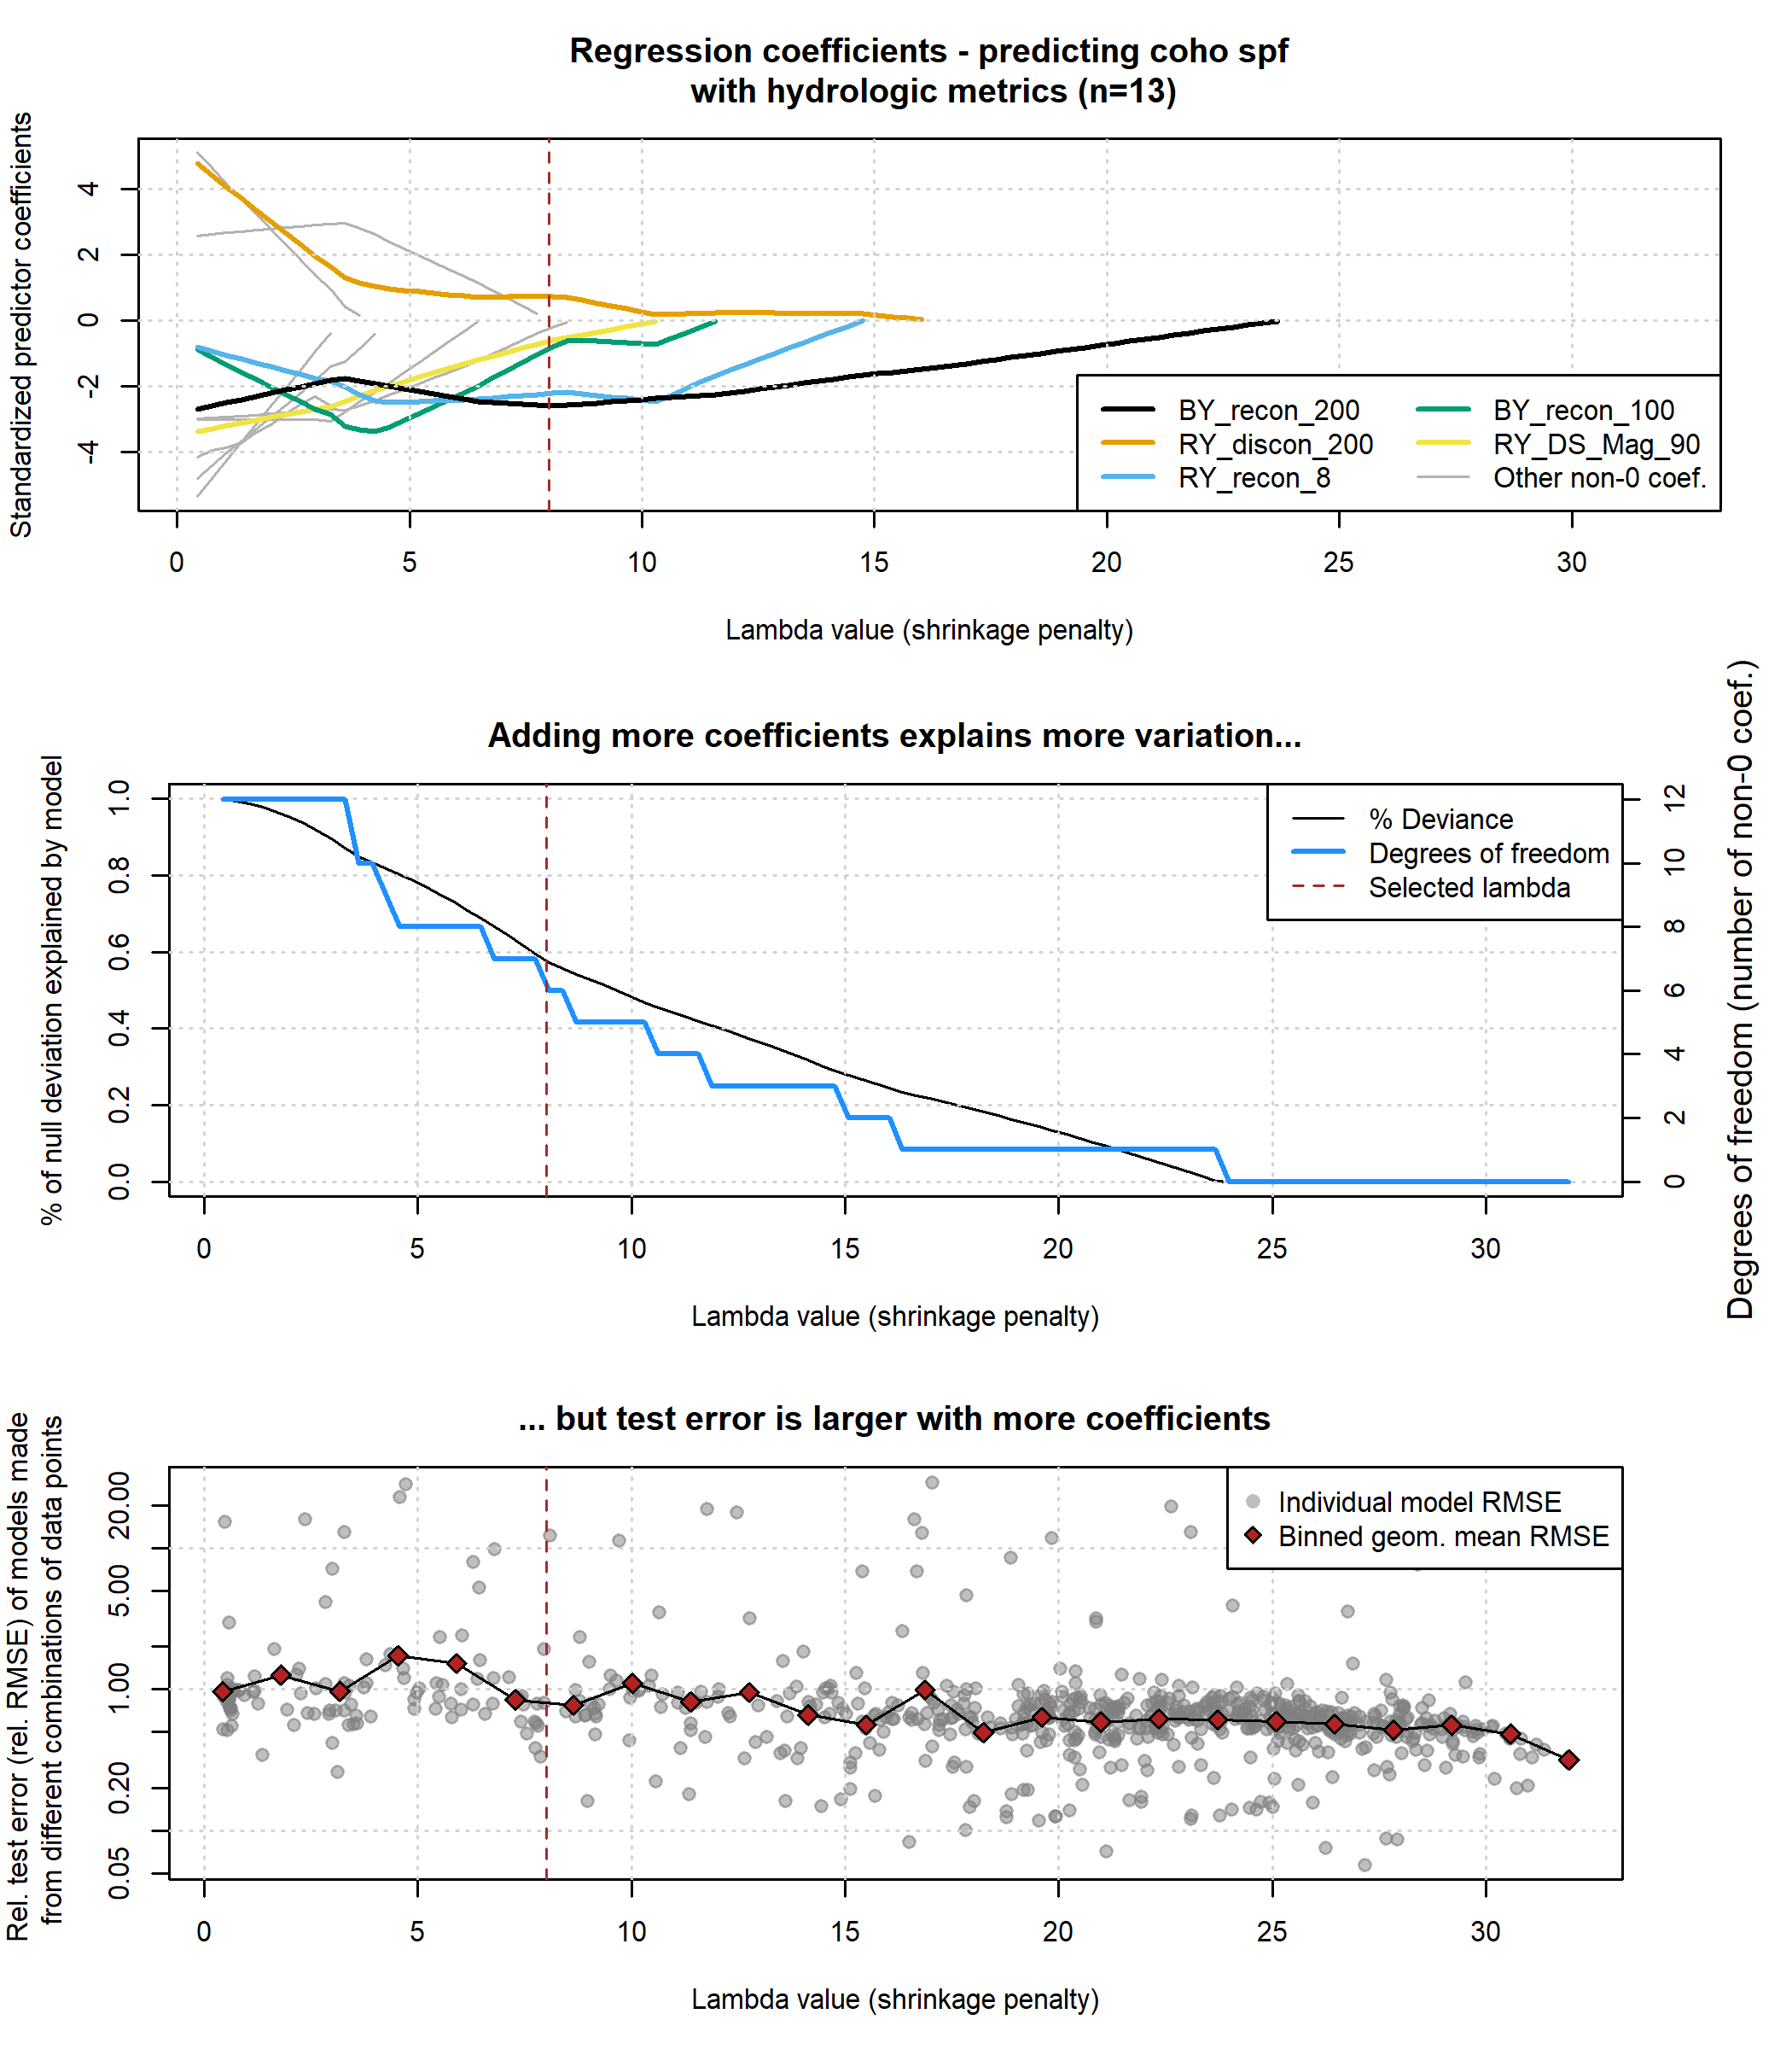

Figure 9: Results of lasso regression to predict coho outcomes with hydrologic metrics. Higher values of lambda tend to shrink the absolute values of regression coefficients toward 0 (top panel). Models with more coefficients explain a greater degree of variation in the dataset (middle panel), but also produce higher test errors (lower panel), indicating some overfitting at lower lambda values.

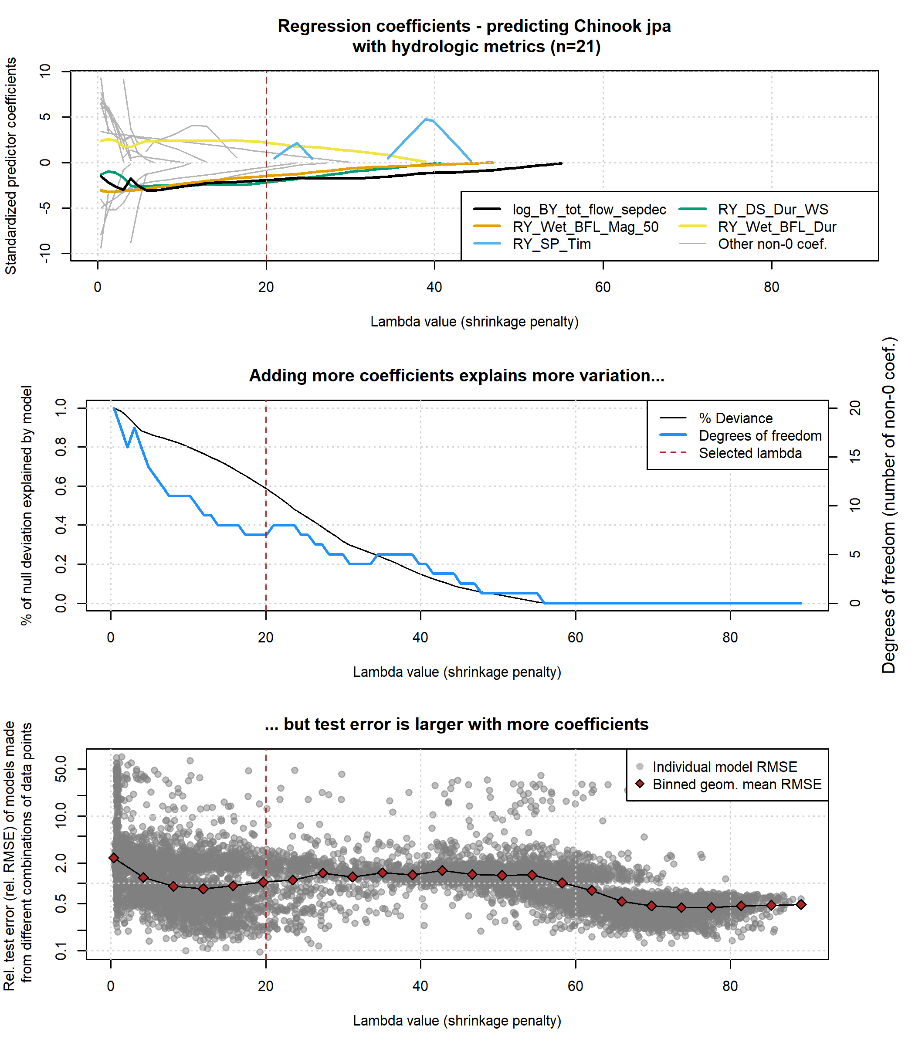

Figure 10: Results of lasso regression to predict Chinook outcomes with hydrologic metrics. Higher values of lambda tend to shrink the absolute values of regression coefficients toward 0 (top panel). Models with more coefficients explain a greater degree of variation in the dataset (middle panel), but also produce higher test errors (lower panel), indicating some overfitting at lower lambda values.

### 4.3.1 Ranked predictor importance

The number of predictors (i.e., the number of non-0 coefficients) incorporated in these models ranged from zero (i.e., the model consisted of the intercept value only) to a maximum of 20 and 27 for coho and Chinook respectively.

* As expected in lasso regression, the predictors most correlated with the selected ecological responses (Figure 8) are identified as the most important predictors in terms of the order in which they are incorporated into the predictive model (Figure 8; Tables 3 and 4).
* example of the above

Table 3: Predictors informing the lasso regression for coho spfat decreasing lambda values (also referred to as a shrinkage penalty). Lambda values represent the point at which a non-0 coefficient appears for the designated predictor.

| Predictor | Lambda value |
| --- | --- |
| BY_recon_200 | 23.67 |
| RY_discon_200 | 16.03 |
| RY_recon_8 | 14.75 |
| BY_recon_100 | 11.57 |
| RY_DS_Mag_90 | 10.30 |
| RY_recon_70 | 8.39 |
| SY_discon_70 | 7.75 |
| RY_Wet_Tim | 6.48 |
| BY_recon_15 | 4.25 |
| SY_discon_200 | 3.93 |
| BY_recon_70 | 3.30 |
| RY_discon_100 | 3.30 |

Table 4: Predictors informing the lasso regression for Chinook jpaat decreasing lambda values (also referred to as a shrinkage penalty). Lambda values represent the point at which a non-0 coefficient appears for the designated predictor.

| Predictor | Lambda value |
| --- | --- |
| log_BY_tot_flow_sepdec | 55.06 |
| RY_Wet_BFL_Mag_50 | 46.98 |
| RY_SP_Tim | 44.29 |
| RY_DS_Dur_WS | 40.71 |
| RY_Wet_BFL_Dur | 38.91 |
| RY_DS_Mag_90 | 29.94 |
| BY_min_flow_sepdec | 27.25 |
| BY_recon_8 | 23.67 |
| RY_DS_Tim | 16.49 |
| RY_discon_300 | 12.91 |
| RY_recon_8 | 11.11 |
| RY_discon_200 | 10.22 |
| RY_discon_150 | 6.63 |
| BY_num_days_gt_90_pctile | 5.73 |
| BY_recon_40 | 4.83 |
| RY_SP_ROC | 4.83 |
| RY_discon_500 | 3.94 |
| RY_recon_40 | 3.94 |
| BY_recon_150 | 3.04 |
| RY_discon_400 | 3.04 |
| RY_discon_750 | 3.04 |
| RY_discon_15 | 1.25 |
| RY_recon_10 | 0.35 |
| RY_min_flow | 0.35 |

### 4.3.2 Variation explained at different lambda values

* coho % smolt survival - more variation explained with fewer coefficients than chinook juv per adult
* possible interp: in this watershed, Chinook outcomes are less sensitive to flow (or less limited by flow) than coho outcomes
* explanation of “good” years much worse for chinook

## 4.4 Hydrologic Benefit Function

### 4.4.1 Predictors and coefficients in the selected models

Coho y val: coho_smolt_per_fem Coho lambda: 8 Coho RMSE: 23.2920742 Coho relative RMSE: 0.4053561

Coho y val: chinook_juv_per_adult Chinook lambda: 20 Chinook RMSE: 77.8580227 Chinook relative RMSE: 0.5888139

### 4.4.2 Hydrologic Benefit value over time and component contributions

**revise text below**

Matching the historical flow trends discussed above (and tabulated in *Supplemental Table 2*), the predicted value of coho spf-equivalent produced by a given water year has trended downward over time (Figure 11). The hydrology of a severe drought in water years 2012-2016 is reflected in three consecutive years (2014-2016) of predicted coho spf being lower than 40.

Since 1990, the low predicted coho spf values in dry water years have become progressively lower, culminating in three years, all occurring after water year 2000, in which < 0 coho spf are predicted. Though a negative value for coho reproduction has no physical meaning, we chose to retain these impossible values to visually represent uncertainty associated with this modeling exercise (see Discussion for more information).

The relative influence of different terms in the ensemble average model varies over time: most variability in the 1940s-1970s is due to changes in wet season onset and wet season baseflow duration, but starting in the 1980s the fall flow reconnection timing tends to dominate predictions, especially during low-coho spf years (Figure 12; the intercept term is excluded for ease of visualization).

## png   
## 2

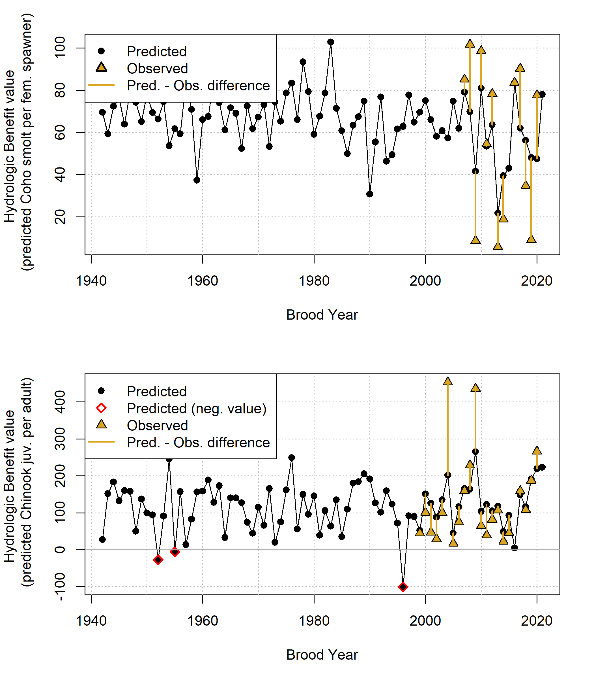

Figure 11: Annual observed and predicted values of coho smolt produced per female spawner (coho spf). Predicted coho spf quantities are shown as Hydrologic Benefit (HB) function values. The coho spf values are plotted in the water year spanning each cohort’s Brood and Rearing Year. Negative prediction values (considered physically impossible) are flagged but are retained to visually demonstrate the uncertainty in the exercise of predicting fish outcomes from hydrologic metrics alone, based on a small sample size.

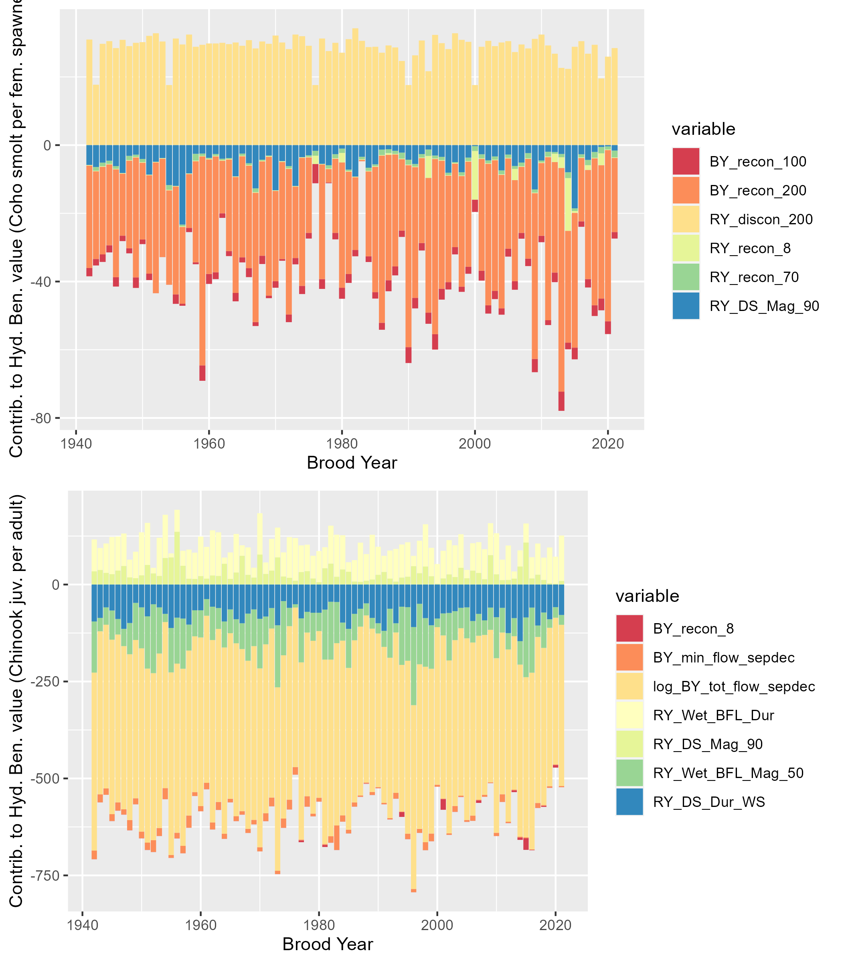

Figure 12: Contributions to annual Hydrologic Benefit values (coho spf-equivalent). A positive value (i.e., one associated with a water year’s Wet Season Baseflow Duration) indicates that a longer wet season baseflow duration contributes a positive value to the predicted number of coho spf produced in that cohort. A negative value (e.g., one associated with a water year’s Fall Reconnection Day at 10 cfs) indicates that a later reconnection date contributes a negative value to the predicted number of coho spf produced in that cohort.

# 5 Discussion

### 5.0.1 Selection of thresholds for flow reconnection and disconnection dates

Discussion

* We did this because the correlation analysis did not identify multiple
* In this watershed, salmon passage to access the lower mainstem is possible at a Fort Jones flowrate (~20-40 cfs), while access to upper tributaries is generally associated with a Fort Jones flowrate of 100 cfs (Sommarstrom 2020).

## 5.1 Previous work on hydrologic indices and ecological responses

In many previous studies of flow-ecology relationships, all the predictors used to model the ecological response are flow-derived metrics, because flow data is often continuous and more abundant than other data types. Such models rely on the assumption that spatial habitat extent (with flow as its proxy) or flow availability is the limiting factor in ecological recruitment, and thus that change in flow can be directly translated to a fish population response. However, this ignores ecological theory. Under many circumstances, complex internal population feedbacks (such as high juvenile fish density leading to some juvenile fish mortality) will be the limiting factor on fish population size. Consequently, many authors have argued that models of fish population responses to hydrologic changes should explicitly include ecological population modeling in addition to physical factors such as flow or geomorphology (J. Rosenfeld 2003; Anderson et al. 2006; Lancaster and Downes 2014; Acreman et al. 2014; Shenton et al. 2012). Additionally, in at least one case, fish population differences were not successfully predicted with a model based only on a predictor of flows; other variables such as water temperature were necessary to capture population shifts (Ryan A. McManamay et al. 2013).

In spite of these known limitations, the HB function proposed here uses only hydrologic predictors. In part this is a pragmatic approach, as this work is intended to set the foundation for assessing flow conditions in speculative hydrologic models, which do not simulate non-hydrologic, ecologically-relevant factors such as water quality or internal population dynamics. Furthermore, the hydrologic-only predictor approach may be more valid in this watershed than in a general case, as previous work suggests that flow availability is the major limiting factor on the local salmon fishery (SRWC and Siskiyou RCD 2005; NMFS 2014). Lastly, the proposed HB function avoids some of the disadvantages of the snapshot method of comparing the two states of natural and altered flows (Wheeler, Wenger, and Freeman 2018), because the hydro-ecological dataset is relatively long. This temporal structure, covering a wide range of water year types, makes it possible to test the hypothesis that a measurable relationship exists between hydrologic signal and ecologic response, even within an otherwise more complex relationship involving many non-hydrologic factors.

## 5.2 Critical flow thresholds

The river reconnection dates of multiple flow thresholds are correlated, to varying degrees, with biological monitoring data (see Results). These correlations support the current scientific understanding that the timing of restoration of habitat connectivity after dry periods in the Scott River is related to the reproductive success of spawning salmon (e.g., Siskiyou County 2021; *pers. comm.*, Sommarstrom 2020; SRWC 2018).

The selection of 10 and 100 cfs thresholds for fall flow reconnection dates is informed by both the empirical relationship between thresholds and coho spf observations (Figure ??) and professional judgment regarding which flows typically facilitate coho spawning passage into the valley and access to a large amount of tributary habitat. However, multiple caveats apply to these thresholds. First, though the timing of the 10 cfs reconnection had the strongest correlation with observed coho spf values, a flow of 18 to 25 cfs has been reported in stakeholder meetings as the minimum flowrate during which fish can pass upriver into Scott Valley (SVGAC 2020). Second, the extent to which the flow at the Fort Jones gauge represents conditions in the rest of the watershed depends on the speed of hydrologic processes taking place. When the transition from the dry season to the wet season is especially abrupt, flow in the tributaries may increase hours before the Fort Jones gauge flow responds (e.g. as was observed in response to the storm in late October of 2021).

Additional fish population monitoring in future water years will be instrumental in better constraining the nuances of these hydro-ecological relationships and the conditions in which hydrology can be used to predict outcomes for anadromous fish.

## 5.3 Predictability of Chinook versus coho salmon

* **correlations between ecological metrics**
* **smolt abundance estimates bias high or low?**

In the dataset evaluated here, hydrologic metrics have a much greater capacity to predict reproduction in coho salmon than in Chinook. This difference may be due to any number of distinctions in the life history and reproductive strategies of the two species (see Section 2.2.4). Some possibilities include:

* Coho salmon prefer smaller tributary stream habitat for spawning, while Chinook prefer larger gravels found on the mainstem of the Scott River. Consequently, coho salmon may be more sensitive to the amount of river connectivity and thus total salmon-accessible habitat during their spawning window.
* Chinook typically do not oversummer in the freshwater system, potentially making them less vulnerable than coho to dry season conditions.
* Chinook populations may be more strongly affected by ocean conditions than coho salmon, possibly due to behavior differences during their period of ocean residence, which is not examined here. This factor may exert a more powerful control on the number of returning spawners than freshwater conditions.

Regardless of the ultimate cause(s), this difference in predictability underscores the fact that the prediction exercise undertaken in this study can only be performed successfully for some species and some regions.

## 5.4 Hydrologic Benefit (HB) function predictive performance and sensitivity

For the 11 years in which observed coho spf values are available, the HB function was reasonably accurate in its predictions (Figure 11). In particular, it succeeded in predicting whether a coho spf year would be above or below 40 (an arbitrary threshold based on visual inspection of the grouping of the 11 observed values). A more conservative use of this model would be to assign a high-low threshold, and categorize each water year as a “high-coho spf” or “low-coho spf” year based on its relation to this threshold. However, for purposes of this discussion we retain the full distribution of values.

These linear models have been developed for a Coho Freshwater Life Period (see Figure 3 ), but the relevant time period for decisionmakers is typically a water year or shorter. It was possible to select a set of best models that fit within one water year, in that they range from the fall of the Brood Year through the wet season of the immediately following Rearing Year. With this formulation, a prediction could be made each fall, using the flow record of the preceding water year and the estimated number of female spawners during the previous fall-winter, regarding the number of smolts to be observed in the coming spring. This smolt abundance prediction could be made to test the model quality when confronted with new data.

The predictive power of the Hydrologic Benefit formula beyond the hydrologic conditions of water years 2007-2020 remains untestable; for this reason the coho spf prediction values of water years pre-2007 should be treated with skepticism. Notably, the hydrologic phenomena that constitute the limiting factors on salmon reproduction might have been very different in the watershed in past decades (e.g., if fall flows were not a major constraint, then spring rearing habitat, or possibly scouring storm flows in winter, might show stronger correlations with coho reproduction).

Additionally, the sensitivity exercise indicated that even one additional data point can alter the ensemble coefficient, or weight, of the most important predictor (Brood Year reconnection timing, 10 cfs) by at least 24%; thus it is reasonable to assume that if more data is collected in the future, the HB function coefficients and possibly even the set of best hydrologic predictors may shift. Nevertheless, the limited data available can be used to draw some preliminary conclusions regarding bio-hydrologic relationships in the Scott River watershed.

## 5.5 Metric weights and importance

The relative contributions of each metric, shown in Figure 12, indicate that the weighted metric introducing the greatest variability in coho spf predictions is the reconnection date at the 10 cfs threshold; in other words, an important common feature of the water years that yield very low coho spf predictions is a relatively long fall period of flow <10 cfs.

Figure 12 also highlights that three of the four selected hydrologic metrics are negatively correlated with coho spf values. This means the HB function relies on a positive intercept value to generate positive coho spf predictions, and because the intercept value can be outweighed by combinations of flow metric values that are within the range of possibility, this formulation allows the prediction of negative values. A negative value, or a prediction of coho smolt consumption rather than production, is obviously not possible based on our understanding of the coho salmon life cycle (Figure 3).

Unfortunately, observed coho spf values are not available for any of the water years in which a negative value is predicted (2002, 2016 and 2021; Figure 11), so a direct comparison of prediction accuracy is not possible in these water years. However, given that the coho run persisted in the Scott River watershed beyond the 3-year cohort-return interval (i.e., water years 2005 and 2019), some smolt production greater than 0 in these years is highly likely.

The metrics most related to watershed-scale coho spf occur during the window of their parents’ spawning and, to a lesser extent, in the winter through summer of their early rearing. At least three potential mechanisms have been hypothesized regarding the importance of fall flow timing and magnitude to coho salmon. During dry water years, when fall reconnection dates are delayed, coho have been known to spawn in suboptimal habitat (e.g., Siskiyou RCD 2014). Eggs laid in suboptimal conditions suffer from higher mortality rates for multiple reasons, including egg burial by transported sediment, channel bed scouring, or unfavorable water quality (Bjornn and Reiser 1991). Additionally, anadromous fish do not eat during spawning, and a delayed reconnection date, with a corresponding longer waiting period before spawning habitat becomes accessible, leads to higher rates of exhaustion and potentially higher mortality during spawning in long high-elevation spawning migrations (e.g., sockeye salmon in Crossin et al. 2004). Finally, early reconnection flows and related access to more and higher-quality habitat may allow spawning salmon to select more favorable nesting sites, which could exert a controlling influence on the mortality rates of the young produced that year.

It is also notable that the metrics with the highest predictive power are associated with negative values, or coho spf penalties. One possible interpretation is that hydrologic metrics can be useful for identifying unfavorable conditions for coho salmon, but are not sufficient to describe favorable conditions. The ecological theory that may explain this further is beyond the scope of this paper, but could be a focus of future studies.

## 5.6 Implications for water and fisheries management

This study represents a contribution to the large body of work seeking to understand and conserve aquatic ecosystems in the Klamath basin, and in aquatic ecosystems in Mediterranean climates more generally. Viability of the SONCC ESU population of coho salmon has been examined at a regional scale in the past, though conclusions were preliminary, due to data limitations (Williams et al. 2006, 2008). A proposed framework to assess viability included the following factors (Williams et al. 2008):

* Effective population size
* Population size per generation
* Population decline (rate of decline)
* Catastrophic decline (order of magnitude decline within 1 generation)
* Spawner density
* Potential spatial habitat capacity, in units of Intrinsic Potential (IP)
* Hatchery influence
* Extinction risk from population viability analysis model

This work can potentially help managers understand some of the mechanisms driving the population size per generation dimension of this viability schematic - though its predictive power is limited to being relative to the size of the escapement.

We note also that any adaptive management other than flow management (e.g., water use or habitat restoration) will introduce (and surely has already introduced) confounding factors into this modeling exercise. For example, extreme dry conditions and high occurrence of fish stranding in water year 2014 led agencies and local organizations to conduct an unprecedented juvenile salmon rescue operation (CDFW 2015a). It is possible the coho spf for water year (and Rearing Year) 2014 would have been even lower without that intervention (although this is hard to judge; it is also possible that the translocation stressed the fish and may have led to increased mortality rates). Future work may be able to estimate the independent coho population impact of these non-flow adaptive management tactics.

We expect pieces of this approach could be employed in other regional studies, though in systems with shorter or minimal ecological monitoring records, opportunities to find correlations between flow and biological metrics may be sample size-limited to an even greater degree than in this study. However, this study may show the value of even a dozen years of monitoring data in a range of water year types, and could provide motivation to continue investing in data collection and the monitoring of sensitive species.

# 6 Conclusions

This case study uses the functional flow framework and long-term biological monitoring to relate hydrologic conditions to watershed-scale anadromous fish reproduction rates. The empirical flow-biology relationships evaluated here also suggest hypotheses regarding the watershed-specific mechanisms of ecological response to flow variability.

To learn if it was possible to empirically quantify a hydrologic regime that meets the ecological needs of coho salmon in the Scott River watershed, we examined correlations between several dozen hydrologic metrics and local salmon observations. We found several metrics, both from prior studies (Patterson et al. 2020; Yarnell et al. 2020) and designed for this study (Figure 5), that appeared correlated with the number of coho smolts produced per female spawner (coho spf). The two flow metrics most correlated with the coho spf of a given smolt cohort were the first date after the dry season of flows rising above 10 and 100 cfs, respectively, during the spawning window for the cohort’s parents. This suggests that in the Scott River watershed, flow conditions and habitat access during spawning may be the greatest single factor in a brood’s success, affecting the cohort from the egg stage through outmigration to the ocean.

We used linear models to predict coho spf values for each water year based on potential combinations of one and two hydrologic metric predictors. The intercept and slopes of the three best of these linear models were aggregated to formulate a Hydrologic Benefit function (Figure 11). With this formulation, a prediction could be made each fall, using the flow hydrology of the preceding water year and the estimated number of female spawners during the previous fall-winter, regarding the number of smolts to be observed in the coming spring. It can also be applied to the river flow output of hydrologic models simulating various management scenarios, to estimate the impact of infrastructure or regulation on local salmon reproduction.

Conversely, we did not find that Chinook reproduction observations could be predicted with as much success as coho using the same set of hydrologic data. This suggests that the utility of this type of analysis is both region- and species-dependent.

With continuing trends of a narrowing wet season in the Scott River watershed (e.g., Figure 7), entities aiming to sustain local fisheries may find themselves working with ever-thinner margins for error. Globally, in communities living and working with local natural resources, climate change may transform biodiversity-preservation activities into long-term engineering of novel ecosystems. If this occurs, long-term monitoring and frequently re-evaluated flow-ecology relationships will be necessary to support such efforts.

# 7 scratch work

## 7.1 linear modeling

## 7.2 threshold selection

## 7.3 best LM summary

## 7.4 loocv scribbling

## 7.5 HB formula

Acero Triana, Juan S., Maria L. Chu, and Jeffrey A. Stein. 2021. “Assessing the impacts of agricultural conservation practices on freshwater biodiversity under changing climate.” *Ecological Modelling* 453 (September 2020): 109604. <https://doi.org/10.1016/j.ecolmodel.2021.109604>.

Acreman, Mike, Angela H. Arthington, Matthew J. Colloff, Carol Couch, Neville D. Crossman, Fiona Dyer, Ian Overton, Carmel A. Pollino, Michael J. Stewardson, and William Young. 2014. “Environmental flows for natural, hybrid, and novel riverine ecosystems in a changing world.” *Frontiers in Ecology and the Environment* 12 (8): 466–73. <https://doi.org/10.1890/130134>.

Agrawal, A, R S Schick, E P Bjorkstedt, R G Szerlong, M N Goslin, B C Spence, T H Williams, and K M Burnett. 2005. “NOAA Technical Memorandum NMFS PREDICTING THE POTENTIAL FOR HISTORICAL COHO , CHINOOK AND STEELHEAD HABITAT IN NORTHERN CALIFORNIA.” June. Santa Cruz, CA: NOAA National Marine Fisheries Service (NMFS).

Alomía Herrera, Ilia, and Patricia Carrera Burneo. 2017. “Environmental flow assessment in Andean rivers of Ecuador, case study: Chanlud and El Labrado dams in the Machángara River.” *Ecohydrology and Hydrobiology* 17 (2): 103–12. <https://doi.org/10.1016/j.ecohyd.2017.01.002>.

Anderson, Kurt E., Andrew J. Paul, Edward McCauley, Leland J. Jackson, John R. Post, and Roger M. Nisbet. 2006. “Instream flow needs in streams and rivers: The importance of understanding ecological dynamics.” *Frontiers in Ecology and the Environment* 4 (6): 309–18. [https://doi.org/10.1890/1540-9295(2006)4[309:IFNISA]2.0.CO;2](https://doi.org/10.1890/1540-9295(2006)4%5b309:IFNISA%5d2.0.CO;2).

Arthington, A. H., J. M. Bernardo, and M. Ilhéu. 2014. “Temporary Rivers: Linking Ecohydrology, Ecological Quality and Reconciliation Ecology.” *River Research and Applications* 30 (August): 1209–15. <https://doi.org/10.1002/rra>.

Ayllón, Daniel, Graciela G. Nicola, Irene Parra, Benigno Elvira, and Ana Almodóvar. 2014. “Spatio-temporal habitat selection shifts in brown trout populations under contrasting natural flow regimes.” *Ecohydrology* 7: 569–79. <https://doi.org/10.1002/eco.1379>.

Bjornn, T. C., and D. W. Reiser. 1991. “Habitat Requirements of Salmonids in Streams.” In *Influences of Forest and Rangeland Management on Salmonid Fishes and Their Habitats*, edited by W. R. Meehan, 83–138. Special Publication 19. Bethesda, Maryland: American Fisheries Society. <https://doi.org/10.2307/1446234>.

Booth, Derek B., Yantao Cui, Zooey Diggory, Dirk Pedersen, Jordan Kear, and Michael Bowen. 2014. “Determining appropriate instream flows for anadromous fish passage on an intermittent mainstem river, coastal southern California, USA.” *Ecohydrology* 7: 745–59. <https://doi.org/10.1002/eco.1396>.

Bourret, Samuel L., Christopher C. Caudill, and Matthew L. Keefer. 2016. “Diversity of juvenile Chinook salmon life history pathways.” *Reviews in Fish Biology and Fisheries* 26 (3): 375–403. <https://doi.org/10.1007/s11160-016-9432-3>.

Bower, Luke M., Brandon K. Peoples, Michele C. Eddy, and Mark C. Scott. 2022. “Quantifying flow–ecology relationships across flow regime class and ecoregions in South Carolina.” *Science of the Total Environment* 802: 149721. <https://doi.org/10.1016/j.scitotenv.2021.149721>.

Bradford, Michael J, Garth C Taylor, J Andrew Allan, Michael J Bradford, Garth C Taylor, J Andrew Allan Empirical, Michael J Bradford, Garth C Taylor, and J Andrew Allan. 2016. “Empirical Review of Coho Salmon Smolt Abundance and the Prediction of Smolt Production at the Regional Level.” *Transactions of the American Fisheries Society* 126 (June): 48–64. [https://doi.org/10.1577/1548-8659(1997)126<0049](https://doi.org/10.1577/1548-8659(1997)126%3c0049).

Bradley, D. C., M. J. Streetly, D. Cadman, M. Dunscombe, E. Farren, and A. Banham. 2017. “A hydroecological model to assess the relative effects of groundwater abstraction and fine sediment pressures on riverine macro-invertebrates.” *River Research and Applications* 33 (10): 1630–41. <https://doi.org/10.1002/rra.3191>.

Brand, L. Arriana, Juliet C. Stromberg, David C. Goodrich, Mark D. Dixon, Kevin Lansey, Doosun Kang, David S. Brookshire, and David J. Cerasale. 2011. “Projecting avian response to linked changes in groundwater and riparian floodplain vegetation along a dryland river: a scenario analysis.” *Ecohydrology* 4 (July): 130–42. <https://doi.org/10.1002/eco>.

Brown, Larry R., Peter B. Moyle, and Ronald M. Yoshiyama. 1994. “Historical Decline and Current Status of Coho Salmon in California.” *North American Journal of Fisheries Management* 14 (2): 237–61. [https://doi.org/10.1577/1548-8675(1994)014<0237:hdacso>2.3.co;2](https://doi.org/10.1577/1548-8675(1994)014%3c0237:hdacso%3e2.3.co;2).

Brummer, T. J., A. E. Byrom, J. J. Sullivan, and P. E. Hume. 2016. “A QUANTITATIVE FRAMEWORK TO DERIVE ROBUST CHARACTERIZATION OF HYDROLOGICAL GRADIENTS.” *River Research and Applications* 32 (February): 1517–29. <https://doi.org/10.1002/rra>.

Bunn, Stuart E., and Angela H. Arthington. 2002. “Basic principles and ecological consequences of altered flow regimes for aquatic biodiversity.” *Environmental Management* 30 (4): 492–507. <https://doi.org/10.1007/s00267-002-2737-0>.

Bustard, David R., and David W. Narver. 1975. “Aspects of the Winter Ecology of Juvenile Coho Sahnon (Oncorhynchus kisutch) and Steelhead Trout (Salmo gairdneri).” *Journal of the Fish Resources Board of Canada* 32: 667–80.

California Department of Fish and Wildlife (CDFW). 2015a. “Cooperative Report of the Scott River Coho Salmon Rescue and Relocation Effort: 2014 Drought Emergency.” August. California Department of Fish; Wildlife (CDFW). [https://www.fs.usda.gov/Internet/FSE{\_}DOCUMENTS/stelprd3850544.pdf](https://www.fs.usda.gov/Internet/FSE%7b_%7dDOCUMENTS/stelprd3850544.pdf).

———. 2015b. “Recovery Strategy for California Coho Salmon Progress Report 2004-2012.” California Department of Fish; Wildlife (CDFW). [http://www.fgc.ca.gov/meetings/2015/Aug/Exhibits/0805{\_}Item{\_}38{\_}CohoStatusReport.pdf](http://www.fgc.ca.gov/meetings/2015/Aug/Exhibits/0805%7b_%7dItem%7b_%7d38%7b_%7dCohoStatusReport.pdf).

———. 2017. “Interim Instream Flow Criteria for the Protection of Fishery.” [file:///Users/kelseymcneill/Downloads/Scott River{\_}FINAL 02-10-17.pdf](C:\\Users\\kelseymcneill\\Downloads\\Scott River{\_}FINAL 02-10-17.pdf).

———. 2021. “Scott River Best Available Scientific Information for Instream Flow Criteria and Potential Next Steps.”

California Department of Water Resources (DWR). 2021. “Sustainable Groundwater Management Act (SGMA) Water Year Type Dataset.” <https://data.cnra.ca.gov/dataset/sgma-water-year-type-dataset>.

California State Water Resources Control Board (SWRCB). 2022. “Establishment of Minimum Instream Flow Requirements, Curtailment Authority, and Information Order Authority in the Klamath Watershed.” Sacramento, CA. [https://www.waterboards.ca.gov/drought/scott{\_}shasta{\_}rivers/docs/2022/klamath-reg-oal-approval-2022.pdf](https://www.waterboards.ca.gov/drought/scott%7b_%7dshasta%7b_%7drivers/docs/2022/klamath-reg-oal-approval-2022.pdf).

Cartwright, Jennifer, Casey Caldwell, Steven Nebiker, and Rodney Knight. 2017. “Putting flow-ecology relationships into practice: A decision-support system to assess fish community response to water-management scenarios.” *Water* 9 (196): 18. <https://doi.org/10.3390/w9030196>.

Catford, Jane A., William K. Morris, Peter A. Vesk, Christopher J. Gippel, and Barbara J. Downes. 2014. “Species and environmental characteristics point to flow regulation and drought as drivers of riparian plant invasion.” *Diversity and Distributions* 20 (9): 1084–96. <https://doi.org/10.1111/ddi.12225>.

Chowdhury, Shahadat, and Patrick Driver. 2007. “An ecohydrological model of waterbird nesting events to altered floodplain hydrology.” In *MODSIM07 - Land, Water and Environmental Management: Integrated Systems for Sustainability, Proceedings*, 2896–2902. Christchurch, NZ.

Crossin, G. T., S. G. Hinch, A. P. Farrell, D. A. Higgs, A. G. Lotto, J. D. Oakes, and M. C. Healey. 2004. “Energetics and morphology of sockeye salmon: Effects of upriver migratory distance and elevation.” *Journal of Fish Biology* 65 (3): 788–810. <https://doi.org/10.1111/j.0022-1112.2004.00486.x>.

Daneshvar, Fariborz, Amir Pouyan Nejadhashemi, Matthew R. Herman, and Mohammad Abouali. 2017. “Response of benthic macroinvertebrate communities to climate change.” *Ecohydrology and Hydrobiology* 17 (1): 63–72. <https://doi.org/10.1016/j.ecohyd.2016.12.002>.

DeWeber, J. Tyrell, and James T. Peterson. 2020. “Comparing Environmental Flow Implementation Options with Structured Decision Making: Case Study from the Willamette River, Oregon.” *Journal of the American Water Resources Association* 56 (4): 599–614. <https://doi.org/10.1111/1752-1688.12845>.

Drake, Daniel J., Kenneth W. Tate, and Harry Carlson. 2000. “Analysis shows climate-caused decreases in Scott River fall flows.” *California Agriculture* 54 (6): 46–49. <https://doi.org/10.3733/ca.v054n06p46>.

Foglia, Laura, Alison McNally, Courtney Hall, Lauren Ledesma, Ryan Hines, and Thomas Harter. 2013. “Scott Valley Integrated Hydrologic Model : Data Collection , Analysis , and Water Budget.” April. University of California, Davis. <http://groundwater.ucdavis.edu/files/165395.pdf>.

Friedman, Jerome, Trevor Hastie, and Rob Tibshirani. 2010. “Regularization Paths for Generalized Linear Models via Coordinate Descent.” *Journal of Statistical Software* 33 (1): 1–22. <https://arxiv.org/abs/0908.3817>.

Gao, Ye, Yong hong Xie, and Dong sheng Zou. 2020. “Hydrological regime change and its ecological responses in East Dongting Lake, China.” *Ecohydrology and Hydrobiology* 20 (1): 142–50. <https://doi.org/10.1016/j.ecohyd.2019.07.003>.

Graham, Rhea. 2012. “Klamath River Basin Restoration Nonuse Value Survey Klamath River Basin Restoration Nonuse Value Survey Final Report Prepared by.” [https://kbifrm.psmfc.org/wp-content/uploads/2016/12/Graham{\_}2012{\_}0010{\_}Klamath-River-Basin-Restoration-Nonuse-Value-Survey-Final-Report.pdf](https://kbifrm.psmfc.org/wp-content/uploads/2016/12/Graham%7b_%7d2012%7b_%7d0010%7b_%7dKlamath-River-Basin-Restoration-Nonuse-Value-Survey-Final-Report.pdf).

Guareschi, S., A. Laini, E. Racchetti, T. Bo, S. Fenoglio, and M. Bartoli. 2014. “How do hydromorphological constraints and regulated flows govern macroinvertebrate communities along an entire lowland river?” *Ecohydrology* 7 (2): 366–77. <https://doi.org/10.1002/eco.1354>.

Guedes, Gustavo Henrique Soares, Tailan Moretti Mattos, Geysa da Silva Camilo, Wagner Uehara, Débora Lisandra de Paiva Ferreira, and Francisco Gerson Araújo. 2020. “Artificial flow regime promotes abiotic and biotic gradients: Testing the concept of longitudinal zonation in an off-river reservoir.” *Ecohydrology and Hydrobiology* 20 (2): 256–64. <https://doi.org/10.1016/j.ecohyd.2020.02.002>.

Gwinn, Daniel C., Leah S. Beesley, Paul Close, Ben Gawne, and Peter M. Davies. 2016. “Imperfect detection and the determination of environmental flows for fish: Challenges, implications and solutions.” *Freshwater Biology* 61 (1): 172–80. <https://doi.org/10.1111/fwb.12684>.

Hain, Ernie F., Jonathan G. Kennen, Peter V. Caldwell, Stacy A. C. Nelson, Ge Sun, and Steven G. McNulty. 2018. “Using regional scale flow–ecology modeling to identify catchments where fish assemblages are most vulnerable to changes in water availability.” *Freshwater Biology* 63 (8): 928–45. <https://doi.org/10.1111/fwb.13048>.

Hale, Robin, Jian D. L. Yen, Charles R. Todd, Ivor G. Stuart, Henry F. Wootton, Jason D. Thiem, John D. Koehn, et al. 2023. “Is my model fit for purpose? Validating a population model for predicting freshwater fish responses to flow management.” *Ecosphere* 14 (9): 1–13. <https://doi.org/10.1002/ecs2.4660>.

Han, Ming, Chengyi Zhao, Gary Feng, Markus Disse, Fengzhi Shi, and Juyan Li. 2015. “An eco-hydrological approach to predicting regional vegetation and groundwater response to ecological water conveyance in dryland riparian ecosystems.” *Quaternary International* 380-381: 224–36. <https://doi.org/10.1016/j.quaint.2015.02.032>.

Harter, Thomas, and Ryan Hines. 2008. “Scott Valley Community Groundwater Study Plan,” 98. <http://groundwater.ucdavis.edu/files/136426.pdf>.

Healey, M. C. 1991. “Life History of Chinook Salmon (Onchorhynchus tshawytscha).” In *Pacific Salmon Life Histories*, edited by C. Groot and L. Margolis, 313–93. Vancouver: University of British Columbia Press.

Herbst, David B., Scott D. Cooper, Robert Bruce Medhurst, Sheila W. Wiseman, and Carolyn T. Hunsaker. 2019. “Drought ecohydrology alters the structure and function of benthic invertebrate communities in mountain streams.” *Freshwater Biology* 64 (5): 886–902. <https://doi.org/10.1111/fwb.13270>.

Hunt, Sharon L, Timothy J Mulligan, and Kenichiro Komori. 1999. “Oceanic feeding habits of chinook salmon, Oncorhynchus tshawytscha, off northern California.” *Fishery Bulletin* 97 (October 1998): 717–21.

James, Gareth, Daniela Witten, Trevor Hastie, and Robert Tibshirani. 2013. *An Introduction to Statistical Learning*. 7th ed. New York: Springer Science+Business Media. <https://doi.org/10.1007/978-1-4614-7138-7>.

Kevic, Maja, Johannes Ortlepp, Uta Mürle, and Christopher T. Robinson. 2018. “Effects of experimental floods in two rivers with contrasting valley morphologies.” *Fundamental and Applied Limnology* 192 (2): 145–60. <https://doi.org/10.1127/fal/2018/1177>.

Knechtle, Morgan, and Diana Chesney. 2012. “2012 Scott River Salmon Studies.” Yreka, CA: California Department of Fish; Wildlife (CDFW). <https://nrm.dfg.ca.gov/FileHandler.ashx?DocumentID=77836>.

Knechtle, Morgan, and Domenic Giudice. 2020. “2019 Scott River Salmon Studies.” 530. Yreka, CA: California Department of Fish; Wildlife (CDFW).

———. 2021. “2020 Scott River Salmon Studies, Final Report.” Yreka, CA: California Department of Fish; Wildlife (CDFW).

———. 2023. “2022 SCOTT RIVER SALMON STUDIES.” Yreka, CA: CDFW.

Knight, Rodney R., Jennifer C. Murphy, William J. Wolfe, Charles F. Saylor, and Amy K. Wales. 2014. “Ecological limit functions relating fish community response to hydrologic departures of the ecological flow regime in the Tennessee River basin, United States.” *Ecohydrology* 7 (5): 1262–80. <https://doi.org/10.1002/eco.1460>.

Konrad, Christopher P., Julian D. Olden, David A. Lytle, Theodore S. Melis, John C. Schmidt, Erin N. Bray, Mary C. Freeman, et al. 2011. “Large-scale flow experiments for managing river systems.” *BioScience* 61 (12): 948–59. <https://doi.org/10.1525/bio.2011.61.12.5>.

Lamouroux, Nicolas, and Jean Michel Olivier. 2015. “Testing predictions of changes in fish abundance and community structure after flow restoration in four reaches of a large river (French Rhône).” *Freshwater Biology* 60 (6): 1118–30. <https://doi.org/10.1111/fwb.12324>.

Lancaster, Jill, and Barbara J. Downes. 2014. “Linking the hydraulic world of individual organisms to ecological processes: putting ecology into ecohydraulics.” *River Research and Applications* 30 (January): 132–33. <https://doi.org/10.1002/rra>.

Larsen, Stefano, Bruno Majone, Patrick Zulian, Elisa Stella, Alberto Bellin, Maria Cristina Bruno, and Guido Zolezzi. 2021. “Combining Hydrologic Simulations and Stream-network Models to Reveal Flow-ecology Relationships in a Large Alpine Catchment.” *Water Resources Research* 57 (4). <https://doi.org/10.1029/2020WR028496>.

Lueders, Mark B., and Ryan A. McManamay. 2023. “Species depletion profiles as an alternative to streamflow alteration thresholds in a hydroecological risk assessment.” *Ecological Indicators* 147 (December 2022): 109989. <https://doi.org/10.1016/j.ecolind.2023.109989>.

Mack, Seymour. 1958. “Geology and Ground-Water Features of Scott Valley Siskiyou County, California.” Geological Survey Water-Supply Paper 1462. <https://pubs.usgs.gov/wsp/1462/report.pdf>.

Massie, Margaret, and Harrison Morrow. 2020. “2020 Scott River Juvenile Salmonid Outmigrant Study.”

Maurer, Sue. 2003. “Scott River Watershed Adult Coho Salmon Spawning Survey December 2002-January 2003.” Etna, CA: Siskiyou RCD.

Mazor, Raphael D., Jason T. May, Ashmita Sengupta, Kenneth S. McCune, Brian P. Bledsoe, and Eric D. Stein. 2018. “Tools for managing hydrologic alteration on a regional scale: Setting targets to protect stream health.” *Freshwater Biology* 63 (8): 786–803. <https://doi.org/10.1111/fwb.13062>.

McMahon, Thomas E. 1983. “Habitat Suitability Index Models: Coho Salmon. U.S. Dept. Int., Fish Wildl. Serv. FWS/OBS-92/10.49.” Fort Collins, CO: U.S. Dept. Int., U.S. Fish; Wildlife Service. FWS/OBS-92/10.49.

McManamay, Ryan A., and Emmanuel A. Frimpong. 2015. “Hydrologic filtering of fish life history strategies across the United States: Implications for stream flow alteration.” *Ecological Applications* 25 (1): 243–63. <https://doi.org/10.1890/14-0247.1>.

McManamay, Ryan A, Donald J Orth, Charles A Dolloff, and David C Mathews. 2013. “Application of the ELOHA Framework to Regulated Rivers in the Upper Tennessee River Basin: A Case Study.” *Environmental Management* 51: 1210–35. <https://doi.org/10.1007/s00267-013-0055-3>.

Mellado-Díaz, Andrés, Jorge Rubén Sánchez-González, Simone Guareschi, Fernando Magdaleno, and Manuel Toro Velasco. 2019. “Exploring longitudinal trends and recovery gradients in macroinvertebrate communities and biomonitoring tools along regulated rivers.” *Science of the Total Environment* 695: 133774. <https://doi.org/10.1016/j.scitotenv.2019.133774>.

Monk, Wendy A., Paul J. Wood, David M. Hannah, Douglas A. Wilson, Chris A. Extence, and Richard P. Chadd. 2006. “Flow variability and macroinvertebrate community response within riverine systems.” *River Research and Applications* 22 (5): 595–615. <https://doi.org/10.1002/rra.933>.

Monk, Wendy A., Paul J. Wood, David M Hannah, and Douglas A Wilson. 2008. “MACROINVERTEBRATE COMMUNITY RESPONSE TO INTER-ANNUAL AND REGIONAL RIVER FLOW REGIME DYNAMICS.” *River Research and Applications* 24: 988–1001.

Moyle, P. B. 2002. *Inland Fishes of California*. University of California Press.

———. 2014. “Novel aquatic ecosystems: the new reality for streams in California and other Mediterranean climate regions.” *River Research and Applications* 30 (January): 1335–44. <https://doi.org/10.1002/rra>.

National Marine Fisheries Service (NMFS). 2014. “Final SONCC Coho Recovery Plan - Scott River Population.” <https://www.fisheries.noaa.gov/resource/document/final-recovery-plan-southern-oregon-northern-california-coast-evolutionarily>.

Nickelson, Thomas E, Jeffrey D Rodgers, Steven L Johnson, and Mario F Solazzi. 1992. “Seasonal Changes in Habitat Use by Juvenile Coho Salmon (Oncorhynchus kisutch) in Oregon Coastal Streams.” *Canadian Journal of Fisheries and Aquatic Sciences* 49: 783–89.

North Coast Regional Water Quality Control Board (NCRWQCB). 2005. “Staff Report for the Action Plan for the Scott River Watershed Sediment and Temperature Total Maximum Daily Loads.” North Coast Regional Water Quality Control Board. [https://www.waterboards.ca.gov/water{\_}issues/programs/tmdl/records/region{\_}1/2010/ref3872.pdf](https://www.waterboards.ca.gov/water%7b_%7dissues/programs/tmdl/records/region%7b_%7d1/2010/ref3872.pdf).

———. 2006. “Action Plan for the Scott River Sediment and Temperature Total Maximum Daily Loads (Basin Plan Language).”

Parry, Ashley. 2013. “Evaluation and modernization of the Scott Valley Irrigation District.” PhD thesis. <https://doi.org/10.1017/CBO9781107415324.004>.

Patterson, Noelle K., Belize A. Lane, Sarah M. Yarnell, Yexuan Qiu, Samuel Sandoval-Solis, and Gregory B. Pasternack. 2020. “A hydrologic feature detection algorithm to quantify seasonal components of flow regimes.” *Journal of Hydrology* 585 (June).

Pearson, Karl. 1895. “Note on Regression and Inheritance in the Case of Two Parents.” *Proceedings of the Royal Society of London Series I* 58 (Jan): 240–42.

Peek, Ryan, Katie Irving, Sarah M. Yarnell, Rob Lusardi, Eric D. Stein, and Raphael Mazor. 2022. “Identifying Functional Flow Linkages Between Stream Alteration and Biological Stream Condition Indices Across California.” *Frontiers in Environmental Science* 9 (January): 1–14. <https://doi.org/10.3389/fenvs.2021.790667>.

Peterson, James T., and Mary C. Freeman. 2016. “Integrating modeling, monitoring, and management to reduce critical uncertainties in water resource decision making.” *Journal of Environmental Management* 183: 361–70. <https://doi.org/10.1016/j.jenvman.2016.03.015>.

Poff, N. L., J David Allan, Mark B Bain, James R Karr, Karen L Prestegaard, Brian D Richter, Richard E Sparks, and Julie C Stromberg. 1997. “A paradigm for river conservation and restoration.” *BioScience* 47 (11): 769–84. <https://doi.org/10.2307/1313099>.

Poff, N. L., Brian D. Richter, Angela H. Arthington, Stuart E. Bunn, Robert J. Naiman, Eloise Kendy, Mike Acreman, et al. 2010. “The ecological limits of hydrologic alteration (ELOHA): A new framework for developing regional environmental flow standards.” *Freshwater Biology* 55 (1): 147–70. <https://doi.org/10.1111/j.1365-2427.2009.02204.x>.

Poff, N. L., and Julie K. H. Zimmerman. 2010. “Ecological responses to altered flow regimes: A literature review to inform the science and management of environmental flows.” *Freshwater Biology* 55 (1): 194–205. <https://doi.org/10.1111/j.1365-2427.2009.02272.x>.

Qian, Kuimei, Xia Liu, and Yuwei Chen. 2016. “Effects of water level fluctuation on phytoplankton succession in Poyang Lake, China – A five year study.” *Ecohydrology and Hydrobiology* 16 (3): 175–84. <https://doi.org/10.1016/j.ecohyd.2016.08.001>.

Quigley, Danielle. 2007. “Final Report Adult Coho Spawning Ground Surveys 2006-2007.” Etna, CA: Siskiyou RCD. <https://www.siskiyourcd.com/resources>.

Quiñones, Rebecca M., Marcel Holyoak, Michael L. Johnson, and Peter B. Moyle. 2014. “Potential factors affecting survival differ by run-timing and location: Linear mixed-effects models of Pacific salmonids (Oncorhynchus spp.) in the Klamath River, California.” *PLoS ONE* 9 (5): 1–12. <https://doi.org/10.1371/journal.pone.0098392>.

R Core Team. 2020. “R: A Language and Environment for Statistical Computing.” Vienna, Austria: R Foundation for Statistical Computing. <https://www.r-project.org/>.

Ranstam, J., and J. A. Cook. 2018. “LASSO regression.” *British Journal of Surgery* 105 (10): 1348. <https://doi.org/10.1002/bjs.10895>.

Richter, Brian D., Andrew T. Warner, Judy L. Meyer, and Kim Lutz. 2006. “A collaborative and adaptive process for developing environmental flow recommendations.” *River Research and Applications* 22 (3): 297–318. <https://doi.org/10.1002/rra.892>.

Riis, Tenna, Alastair M. Suren, Bente Clausen, and Kaj Sand-Jensen. 2008. “Vegetation and flow regime in lowland streams.” *Freshwater Biology* 53 (8): 1531–43. <https://doi.org/10.1111/j.1365-2427.2008.01987.x>.

Robertson, G. Philip, and Scott M. Swinton. 2005. “Reconciling agricultural productivity and environmental integrity: A grand challenge for agriculture.” *Frontiers in Ecology and the Environment* 3 (1 SPEC. ISS.): 38–46. <https://doi.org/10.2307/3868443>.

Rosenfeld, Jordan. 2003. “Assessing the Habitat Requirements of Stream Fishes: An Overview and Evaluation of Different Approaches.” *Transactions of the American Fisheries Society* 132 (5): 953–68. <https://doi.org/10.1577/t01-126>.

Rosenfeld, Jordan S. 2017. “Developing flow–ecology relationships: Implications of nonlinear biological responses for water management.” *Freshwater Biology* 62 (8): 1305–24. <https://doi.org/10.1111/fwb.12948>.

Saby, Linnea, Kevin L. McKee, Prakrut Kansara, Jonathan L. Goodall, Lawrence E. Band, and Venkataraman Lakshmi. 2022. “Sensitivity of Remotely Sensed Vegetation to Hydrologic Predictors across the Colorado River Basin, 2001–2019.” *Journal of the American Water Resources Association* 58 (6): 1017–29. <https://doi.org/10.1111/1752-1688.12965>.

Scott River Coordinated Resource Management Planning Comittee, and Scott River Watershed Council (SRWC). 2000. “Final Report.”

Scott River Water Trust (SRWT). 2018. “2017 Monitoring Report.” June. <https://www.scottwatertrust.org/blank>.

Scott River Watershed Council (SRWC). 2018. “Restoring Priority Coho Habitat in the Scott River Watershed Modeling and Planning Report.” Etna, CA. <https://www.scottriverwatershedcouncil.com/scott-river-westside-planning-proje>.

Scott Valley Area Plan Committee. 1980. “Scott Valley Area Plan (SVAP).”

Shenton, Will, Nicholas R. Bond, Jian D. L. Yen, and Ralph Mac Nally. 2012. “Putting the ecology into environmental flows: Ecological dynamics and demographic modelling.” *Environmental Management* 50 (1): 1–10. <https://doi.org/10.1007/s00267-012-9864-z>.

Sinnathamby, Sumathy, Kyle R. Douglas-Mankin, Muluken E. Muche, Stacy L. Hutchinson, and Aavudai Anandhi. 2018. “Ecohydrological index, native fish, and climate trends and relationships in the Kansas River basin.” *Ecohydrology* 11 (1): 1–18. <https://doi.org/10.1002/eco.1909>.

Siskiyou County Flood Control and Water Conservation District. 2021. “Scott Valley Groundwater Sustainability Plan.” Siskiyou County Flood Control; Water Conservation District. <https://www.co.siskiyou.ca.us/naturalresources/page/scott-valley-gsp-chapters>.

Siskiyou County GSA - Scott Valley Groundwater Advisory Committee. 2020. “Siskiyou County Groundwater Sustainability Agency Scott Valley Groundwater Advisory Committee Meeting.” Fort Jones, CA: Siskiyou County. <https://www.co.siskiyou.ca.us/scottvga/page/scott-valley-groundwater-advisory-committee-meeting-10>.

Siskiyou RCD. 1994. “Scott Valley Irrigation District Study.”

———. 2004. “Final Report. Scott River Coho Spawning Assessment: 2003-2004.” <https://www.siskiyourcd.com/resources>.

———. 2005. “Scott River Watershed Adult Coho Spawning Ground Surveys. November 2004-January 2005.” Etna, CA. <https://www.siskiyourcd.com/resources>.

———. 2006. “Final Report Scott River Adult Coho Spawning Ground Surveys November 2005 – January 2006.” Etna, CA. <https://www.siskiyourcd.com/resources>.

———. 2010. “Scott River Adult Coho Spawning Ground Surveys December 2009-January 2010.” <https://www.siskiyourcd.com/resources>.

———. 2011. “Scott River adult coho spawning ground surveys, 2010-2011 Season.” Siskiyou RCD. <https://www.siskiyourcd.com/resources>.

———. 2012. “Scott River Adult Coho Spawning Ground Surveys, 2011 Season.” <https://www.siskiyourcd.com/resources>.

———. 2013. “Scott River Adult Coho Spawning Ground Surveys 2012-2013 Season.” <https://www.siskiyourcd.com/resources>.

———. 2014. “Scott River Adult Coho Spawning Ground Surveys 2013-2014 Season.” <https://www.siskiyourcd.com/resources>.

———. 2015a. “Ranch Water Quality Plan Template.” February. Etna, CA. <https://www.siskiyourcd.com/resources>.

———. 2015b. “Scott River Fall Chinook Spawning Ground Surveys.” March. Etna, CA. <https://www.siskiyourcd.com/resources>.

———. 2017a. “Scott River Adult Coho Spawning Ground Surveys 2016-2017 Season Report.” June. Etna, CA. <https://www.siskiyourcd.com/resources>.

———. 2017b. “Scott River Fall Chinook Spawning Ground Surveys.” January. Etna, CA. <https://www.siskiyourcd.com/resources>.

———. 2018. “Scott River Fall Chinook Spawning Ground Surveys 2017 Season.” January. Etna, CA. <https://www.siskiyourcd.com/resources>.

Solans, M. Alba, and D. García de Jalón. 2016. “Basic tools for setting environmental flows at the regional scale: application of the ELOHA framework in a Mediterranean river basin.” *Ecohydrology* 9 (8): 1517–38. <https://doi.org/10.1002/eco.1745>.

Sommarstrom, Sari. 2020. “Email communication regarding connectivity of Scott River tailings reach, Nov. 18, 2020.”

SRWC. 2005. “Initial Phase of the Scott River Watershed Council Strategic Action Plan.” October. Etna, CA. <https://www.siskiyourcd.com/resources>.

SRWC, and Siskiyou RCD. 2003. “Scott River Fall Flows Action Plan Accomplishments, 1995 to 2003.” January. Etna, CA.

Stewart-Koster, B., J. D. Olden, M. J. Kennard, B. J. Pusey, E. L. Boone, M. Douglas, and S. Jackson. 2011. “Fish response to the temporal hierarchy of the natural flow regime in the Daly River, northern Australia.” *Journal of Fish Biology* 79 (6): 1525–44. <https://doi.org/10.1111/j.1095-8649.2011.03072.x>.

Superior Court of Siskiyou County. 1980. “Scott River Adjudication, Decree No. 30662. Scott River stream system, Siskiyou County. California State Water Resources Conrol Board.” Sacramento. [https://www.waterboards.ca.gov/waterrights/board{\_}decisions/adopted{\_}orders/judgments/docs/scottriver{\_}jd.pdf](https://www.waterboards.ca.gov/waterrights/board%7b_%7ddecisions/adopted%7b_%7dorders/judgments/docs/scottriver%7b_%7djd.pdf).

Tarlock, A. Dan. 1993. “Local Government Protection of Biodiversity: What Is Its Niche?” *University of Chicago Law Review* 60 (2): 555–613.

Tesfaye, Samuale, Emiru Birhane, Toon Leijnse, and S. E. A. T. M. van der Zee. 2017. “Climatic controls of ecohydrological responses in the highlands of northern Ethiopia.” *Science of the Total Environment* 609: 77–91. <https://doi.org/10.1016/j.scitotenv.2017.07.138>.

Tolley, Douglas G., Laura Foglia, and Thomas Harter. 2019. “Sensitivity Analysis and Calibration of an Integrated Hydrologic Model in an Irrigated Agricultural Basin with a Groundwater-Dependent Ecosystem.” *Water Resources Research* 55 (8). <https://doi.org/10.1029/2018WR024209>.

U.S. Census Bureau. 2021. “2020 Decennial Census.” <https://data.census.gov/cedsci>.

Van Kirk, Robert W., and Seth W. Naman. 2008. “Relative effects of climate and water use on base-flow trends in the lower Klamath Basin.” *Journal of the American Water Resources Association* 44 (4): 1035–52. <https://doi.org/10.1111/j.1752-1688.2008.00212.x>.

Wainwright, Thomas C, Thomas H Williams, Kurt L Fresh, and Brian K Wells. 2013. “CCIEA Phase II Report: Ecosystem Components, Fisheries and Protected Species - Salmon: CHINOOK AND COHO SALMON.” NOAA NMFS. <https://swfsc-publications.fisheries.noaa.gov/publications/CR/2013/2013Wainwright.pdf>.

Webb, J. Angus, Robyn J. Watts, Catherine Allan, and John C. Conallin. 2018. “Adaptive Management of Environmental Flows.” *Environmental Management* 61 (3): 339–46. <https://doi.org/10.1007/s00267-017-0981-6>.

Welch, David Warren, Aswea Dawn Porter, and Erin Leanne Rechisky. 2021. “A synthesis of the coast-wide decline in survival of West Coast Chinook Salmon (Oncorhynchus tshawytscha, Salmonidae).” *Fish and Fisheries* 22: 194–211. <https://doi.org/10.1111/faf.12514>.

Wheeler, Kit, Seth J. Wenger, and Mary C. Freeman. 2018. “States and rates: Complementary approaches to developing flow-ecology relationships.” *Freshwater Biology* 63 (8): 906–16. <https://doi.org/10.1111/fwb.13001>.

White, James C., Andy House, Neil Punchard, David M. Hannah, Nicholas A. Wilding, and Paul J. Wood. 2018. “Macroinvertebrate community responses to hydrological controls and groundwater abstraction effects across intermittent and perennial headwater streams.” *Science of the Total Environment* 610-611: 1514–26. <https://doi.org/10.1016/j.scitotenv.2017.06.081>.

Williams, Thomas H, Eric P Bjorkstedt, Walt G Duffy, Mike Mccain, Mike Rode, and R Glenn Szerlong. 2006. “Historical population structure of Coho Salmon in Southern Oregon/Northern California coasts evolutionary significant unit.” National Oceanic; Atmosphecric Administration (NOAA) National Marine Fisheries Service (NMFS). <https://repository.library.noaa.gov/view/noaa/3483>.

Williams, Thomas H, Brian C Spence, Tom E Lisle, Thomas E Nickelson, and Tom Pearson. 2008. “Framework for assessing viability of threatened coho salmon in the Southern Oregon/Northern California Coast Evolutionarily Significant Unit.” National Oceanic; Atmosphecric Administration (NOAA) National Marine Fisheries Service (NMFS). <https://repository.library.noaa.gov/view/noaa/3609>.

Worrall, T. P., M. J. Dunbar, C. A. Extence, C. L. R. Laizé, W. A. Monk, and P. J. Wood. 2014. “The identification of hydrological indices for the characterization of macroinvertebrate community response to flow regime variability.” *Hydrological Sciences Journal* 59 (3-4): 645–58. <https://doi.org/10.1080/02626667.2013.825722>.

Yao, Weiwei, Ruidong An, Guoan Yu, Jia Li, and Xiaoyi Ma. 2021. “Identifying fish ecological risk patterns based on the effects of long-term dam operation schemes.” *Ecological Engineering* 159 (March 2020): 106102. <https://doi.org/10.1016/j.ecoleng.2020.106102>.

Yarnell, Sarah M., Eric D. Stein, J. Angus Webb, Theodore Grantham, Rob A. Lusardi, Julie Zimmerman, Ryan A. Peek, Belize A. Lane, Jeanette Howard, and Samuel Sandoval-Solis. 2020. “A functional flows approach to selecting ecologically relevant flow metrics for environmental flow applications.” *River Research and Applications* 36 (2): 318–24. <https://doi.org/10.1002/rra.3575>.

Yokel, E, Shari K Witmore, B Stapleton, C Gilmore, and M M Pollock. 2018. “Scott River Beaver Dam Analogue Coho Salmon Habitat Restoration Program 2017 Monitoring Report.” <https://www.scottriverwatershedcouncil.com/scott-river-beaver-dam-analogue-coh>.